God’s Blessing for You

from Numbers 6:24 – 26 and 1 Thessalonians 5:23 – 24

²⁴ “The Lord bless you and keep you;
²⁵ The Lord make His face shine upon you,
And be gracious to you;
²⁶ The Lord turn toward you,
And give you peace(Shalom).

²³May God himself, the God of peace sanctify you through and through;
May your whole spirit, soul and body be kept blameless at the coming of the Lord
Jesus Christ.
²⁴ The one who has called you is faithful.
And He will do it.
Amen
Aaronic (Priestly) blessing in the Old Testament – Numbers 6:24 – 26
Blessing in New Testament – 1 Thessalonians 5:23 – 24

“GOD’S STORY of Love, Forgiveness, Compassion, Redemption and Grace”
Moses
10 commandments given at Sinai
Tabernacle is built in wilderness
Writes the Torah, Celebrate
Holy Days & Feasts of the Lord (Exodus 23 and Leviticus 23)
Celebrates First Passover
Levitical laws and instructions.
Reads Torah to remind Israelites of God’s instructions and laws.
Dies at Mount Nebo.
Appears with Elijah at Yeshua’s (Jesus) Transfiguration (New Covenant) Genesis - Deuteronomy

God’s instruction book, the Bible; learning from the lives of others.
400 years
Joseph
Favoured Son of Jacob
Governor in Egypt. Were in Egypt ~ 400 years. In Slavery. God saw His children suffering.
Genesis
Jacob
12 sons
Father of the tribes of Israel
Genesis
Isaac
Symbolic sacrificial lamb.
Jacob and
Esau were twins. Jacob is the son of promise.
Genesis
Abraham
(~ 2000 BC)
Chosen by God - is the only righteous man & patriarch of the Nations, named the first Israelite. Had 2 sons Ishmael & Isaac Genesis . Met Melchizedek - a righteous king anointed by God blesses Abraham. King of Salem and priest of God Most High. Genesis

Genesis
Genesis
Noah
The flood
& God’s Promise

Genesis

Creation
God created Heaven & Earth Adam & Eve sinned by eating from the tree of Knowledge of good & evil. Genesis

400 years
Between Old and New Testaments
(~ 167 BCE) Maccabeus revolt, restore the 2nd Temple after it is desecrated by the Assyrians. Chanukkah celebrated.
More of God’s activities are written in books in the Armenian, Orthodox and Ethiopian Bibles.

Exile – Babylon
70 years ~ 607 ~ 538 BCE
Prophets who warned Israelites about exile, lived in exile and books written after the exile.
Isaiah – foretold, warned Israelites about end results of sin
Jeremiah – warned Israelites, coming doom, lamented it.
Exiles: 3 groups exiled ~ 605, 597 and 587 BCE.
Books written during exile:
Daniel – exiled as a young man – 586 BCE
Ezekiel – exiled in Babylon - called to be a prophet
Esther - in Susa, near Babylon ~ 474 BCE
Books written after exile:
After 70 years, Cyrus let Israelites return, exile ended ~ 538
Ezra – Priest, teacher led some Israelites back to Jerusalem, rebuilt the temple. Reads Torah to Israelites to remind them of God’s ways. ~515 BCE the temple is restored.
Nehemiah – Governor rebuilds walls of Jerusalem
Haggai. Zachariah, Malachi (in red - prophets & books of the OT) I & II Chronicles – summary Kings – Micah
Time of the Kings
Saul
David (~ 1000 BCE) (I & II Samuel, Psalms)
Solomon - Builds first temple in Jerusalem Proverbs, Song of Songs
Rehaboam – divides kingdom (Judah & Israel)
Hezekiah, Ahab & Jezebel, Jehu, Jeraboam II Hoshea (last king of Israel), Jorash, Josiah, Zedekiah (last king of Judah), Jehoichakin taken to Babylon.

Prophets with Priests serving the Israelites: II Samuel, I & II Kings, Isaiah, Elijah, Elisha, Jeremiah (also wrote Lamentations), Nahum, Daniel, Ezekiel & Zechariah. God is viewed as Israel’s ultimate King.

Joshua
Leads Children of Israel into Canaan.
Reads Torah to Israelites a number of times who then keep the faith for 2 generations
Book of Joshua
Judges
Eli & sons Joel and Abiah
Othniel,
Ehud,
Shamgar,
Deborah, Gideon, Jephthah, Ibzan, Elon, Abdon, and Samson. Kenaniah and his sons., etc.
Samuel – the last judge during time of King Saul and David. History Books: Samuel, Joshua, Judges, 1 Kings, Chronicles

Redemption

Messiah Returns
Feasts: Rosh Hashanah
Yom Kippur,
Sukkot
Torah, Revelation
Jews are dispersed throughout the world to be a light to the nations.

2nd Temple is destroyed Temple in Jerusalem 70 AD

Yeshua sends out 70
disciples during his ministry…
Is crucified, Resurrected …

Letters, Epistles Romans, Hebrews written to guide believers following Yeshua, obeying Adonai’s Word. Revelation prophesies

Early Church
Receiving the Holy Spirit.
Book of Acts
Jews and Gentiles one in Messiah.

Yeshua selects 12 disciples
Gospels record Yeshua’s life: Matthew,
Mark, Luke & John
Yeshua
(~ 4BC )
Yeshua is born:
3 years of Ministry
Crucified, Resurrected -Will return…

Helen Wall PhD April 2021
Old Covenant/Testament
“GOD’S STORY of Love, Forgiveness, Compassion, Redemption and Grace”
God’s instruction book, the Bible, to learn from the lives of others.
Helen Wall PhD April 2021
Creation
God created Heaven & Earth Adam & Eve sinned by eating from the tree of Knowledge of good & evil. Genesis
Noah
The flood
& God’s Promise

Genesis

Abraham
(~ 2000 BC)
Chosen by God - is the only righteous man & patriarch of the Nations, named the first Israelite.. Had 2 sons Ishmael & Isaac. Melchizedek - a righteous king anointed by God blesses Abraham, King of Salem and priest of God Most High. Genesis

Genesis
Genesis
Isaac
Symbolic sacrificial lamb.
Jacob and
Esau were twins.
Jacob is the son of promise.
Genesis
Jacob
12 sons
Father of the tribes of Israel.
Judah line called the Jews and line of David and Yeshua
Genesis
Joseph
Favoured Son of Jacob
Governor in Egypt. In Egypt ~ 400 years. In Slavery. God saw His children suffering.
Genesis
400 years
Moses
10 commandments given at Sinai
Tabernacle is built in wilderness
Writes the Torah
Holy Days & Feasts of the Lord (Exodus 23 and Leviticus 23)
Celebrates First Passover
Levitical laws and instructions.
Reads Torah to remind Israelites of God’s instructions and laws.
Dies at Mount Nebo.
Appears with Elijah at Yeshua’s (Jesus) Transfiguration (New Covenant)
Genesis - Deuteronomy

Joshua
Leads Children of Israel into Canaan.
Reads Torah to Israelites a number of times. 2 generations keep the faith. Is judge, administrat-or, priest
Book of Joshua
Time of the Kings
Saul
David (~ 1000 BCE) (I & II Samuel, Psalms)
Solomon - Builds first temple in Jerusalem Proverbs, Song of Songs
Rehaboam – divides kingdom (Judah & Israel)
Hezekiah, Ahab & Jezebel, Jehu, Jeraboam II Hoshea (last king of Israel), Jorash, Josiah, Zedekiah (last king of Judah), Jehoichakin taken to Babylon.(see charts)

Prophets with Priests serving the Israelites: II Samuel, I & II Kings, Isaiah, Elijah, Elisha, Jeremiah (also wrote Lamentations), Daniel, Ezekiel & Zechariah. God is viewed as Israel’s ultimate King.

Exile – Babylon
70 years ~ 607 ~ 538 BCE
Prophets who warned Israelites about exile, lived in exile and books written after the exile.
Isaiah – foretold and warned Israelites about sin
Jeremiah – warned Israelites of coming doom
Exiles: 3 groups exiled ~ 605, 597 and 587 BCE.
Books written during exile:
Daniel – exiled as a young man – 586 BCE
Ezekiel – exiled in Babylon - called to be a prophet
Esther - in Susa, near Babylon ~ 474 BCE
Books written after exile:
After 70 years, Cyrus let Israelites return, exile ended ~ 538
Ezra – Priest, teacher led some Israelites back to Jerusalem, rebuilt the temple and reads Torah to Israelites to remind them of God’s ways. ~515 BCE the temple is restored.
Nehemiah – Governor rebuilds walls of Jerusalem
Haggai. Zachariah, Malachi (in red - prophets & books of the OT) , l & ll Chronicles
I & II Chronicles – summary of OT history
400 years
Between Old and New Testaments
(~ 167 BCE) Maccabeus revolt, restore the 2nd Temple after it is desecrated by the Assyrians. Chanukkah celebrated.
More of God’s activities are written in books in the Armenian, Orthodox and Ethiopian Bibles.

Judges
Eli & sons Joel and Abiah
Othniel,
Ehud,
Shamgar,
Deborah, Gideon, Jephthah, Ibzan, Elon, Abdon, and Samson. Kenaniah and his sons., etc.
Samuel – the last judge during time of King Saul and David. History Books: Samuel, Joshua, Judges, 1 Kings, Chronicles

New Covenant/Testament Chart follows completing the Old Covenant when Messiah Returns

New Covenant/Testament details about “God’s Story of Love, Forgiveness, Redemption and Grace
Yeshua
(~ 4BC)
- Yeshua is born
- ~ 3 ½ years of ministry
- Crucified
- Resurrected
- Will return as coming King.
- …
Yeshua selects 12 disciples
Gospels record Yeshua’s life:
- Matthew
- Mark
- John
- Luke
The book of Acts, written by Luke, is a continuation of the book of Luke.
Yeshua sends out 70 disciples during his ministry…
They spread the good news of Yeshua to villages and towns.
Yeshua empowered them and they performed many
Miracles.

Book of Acts - Receiving the Holy Spirit
- 3000 who came from distant lands were in the temple for the feast of Shavout.
- They received the Holy Spirit – this would include Jews who came to believe in Yeshua who were also baptized.
- Speaking in tongues - Came from Distant lands: Parthians and Medes and Elamites and those living in Mesopotamia, Judea and Cappadocia, Pontus and Asia, ¹⁰ Phrygia and Pamphylia, Egypt and parts of Libya toward Cyrene, and visitors from Rome ¹¹ (both Jewish people and proselytes), Cretans and Arabs—we hear them declaring in our own tongues the mighty deeds of God!” (Acts 2:9-12)
- Miracles – Disciples perform

Destruction of the 2nd Temple in Jerusalem 70 AD
(Paul’s writings)

Romans written by Paul was a theological discussion for Jews and Gentile believers (proselytes) in Rome.
Hebrews written to guide new believers following Yeshua and obeying Adonai’s Word. Tracing the Hebrew roots of the faith

Dispersion of the Jews throughout the world to be a light to the nations. (Paul’s writings)

Messiah Returns
(We know not the day or hour)
Jewish Festivals celebrated (Exodus 23, Leviticus 23 & Revelation):
- Rosh Hashanah (Feast of Trumpets)
- Yom Kippur (Day of Atonement)
- Sukkot (Feast of Tabernacles)
Torah, Revelation
Book of Acts
- Receiving the Holy Spirit.
- Jews and Gentiles one in Messiah.
- Paul’s conversion on the road to Damascus
- Beginnings of the early Church
- Miracles of the Disciples
- Paul’s journeys, an emissary of Yeshua.

Paul’s Letters to communities:
Romans, Corinthians, Galatians, Ephesians, Philippians, Colossians, Thessalonians
*Some books may not be classed as Paul’s Letters

Paul’s Pastoral Letters to individuals:
Timothy
Titus
Philemon
*Some books may not be classed as Paul’s Letters

Messianic Letters:
Hebrews (Messianic Jews)
James, Peter, John, Jude
* Complete Jewish Bible
Book of Revelation
God’s revelation to the Apostle John about the end times and Yeshua’s return as the Messiah and coming King.
Helen Wall PhD April 2021
NOTE: Names of Books in red text. References: Complete Jewish Bible; David Stern, 2016
Messiah returns as King
Judgment
1000 year reign

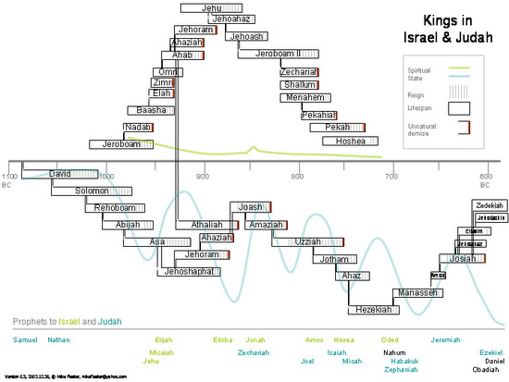
http://www.britam.org/kings.html

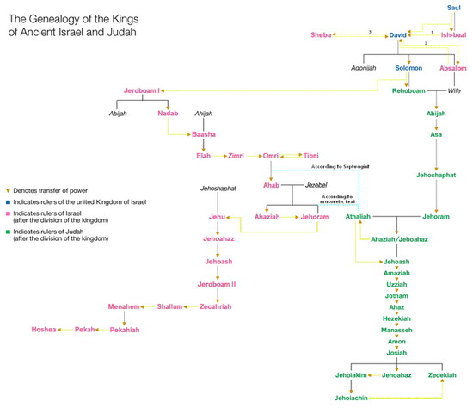
Source of Table:
http://commons.wikimedia.org/wiki/File:Genealogy
_of_the_kings_of_Israel_and_Judah.png

