Draft
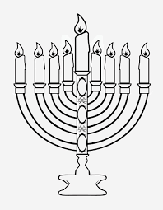Hanukkia – 9 branches and a middle servant candle to light the others.

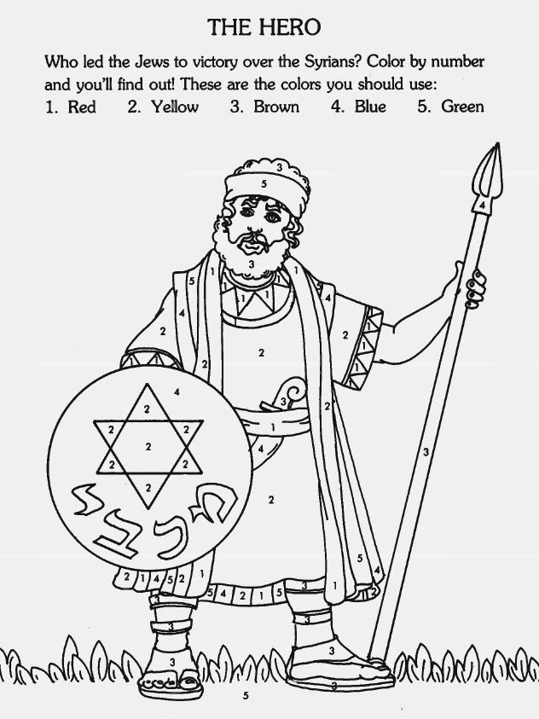
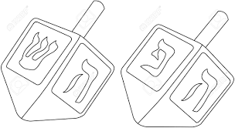
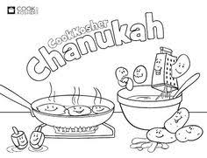
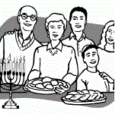
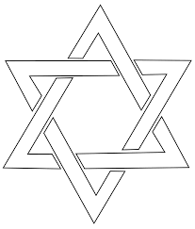
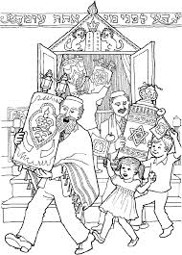
A Celebration and a Feast remembering: that the Temple in Jerusalem was
restored after the Assyrians defiled it in 167 BC and persecuted and dishonoured
the Jewish people.

HISTORY: Mattathias, a devout Jewish priest, was told to slaughter a pig (an unclean
animal) on the altar in the Temple. He refused and killed the officer who demanded this
and also killed the Jew, a traitor, who did slaughter the pig on the altar. Mattathias
tore down the pagan altar and with his family fled to the hills in Judea. After his father died, his son, Judah Maccabee resisted the Syrians. Despite being greatly outnumbered, Judah and his men, mainly through prayer and fasting, managed to gain many astonishing victories over larger foreign armies. Due to their faith, God granted them many victories.
Judah Maccabee and his soldiers defeated Antiochus’ who was the leader of large Assyrian armies. When Judah returned to the temple in Jerusalem to offer sacrifices to the one true God, the temple was dishonoured and destroyed. The Jewish people mourned and then cleansed the Temple, tore down the pagan altar and pagan idols, and brought new uncut stones for the altar, as the Law of Moses required.
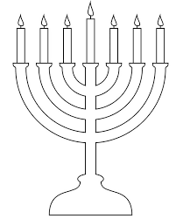

The menorah which represented the light of God had been broken. They brought new vessels,
replaced the altar of incense, the tables and candlesticks. After much work they completed the
repairs on the 25th day of the He day of the Hebrew month of Kislev (roughly December) on our
calendars. This was exactly 3 years after the hatred dishonoured and defiled the
Temple. When they went to light the Menorah (7 branch candle stick)
recognizing the light of God in the temple, they discovered that
they only had enough sacred oil for 1 day. However, to their surprise the oil burned for
8 days. When all the work was done, the grateful and joyful worshipers celebrated the
dedication (Hanukkah) of the Temple to the Lord. Lamps were lit with sacred olive
oil and sacrifices were offered to God. There was singing of songs, with harps, flutes
and cymbals. They worshiped the Lord for giving them victory over their enemies.
It was a memorial to God’s faithfulness.
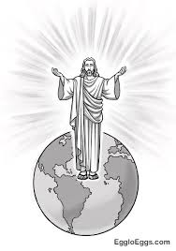

In the New Testament, Jesus attended the feast of dedication
(Hanukkah) in winter time in Jerusalem. Here Jesus declared that he
is the light of the world. John 10:22-25.(beliefs of Christians and Messianic Jews))

Today Jews celebrate Hanukah, lighting the Hanukkia for 8 days,
celebrating the two fold victory of the miraculous oil burning for 8 days
and the military victories. Family time with Special foods, songs,
games and gift giving take place.
Foods include those cooked in oil: Children play a special game using a dreidel
(like a top). They spin it and win candy.

Notes to the Teacher:
- When discussing the Hanukkah celebration examine the things that are done that are common to celebrating Christmas (food and rational for certain foods; family gatherings; playing games; gift giving; singing; decorations etc). The changes in cultural symbols go back to the history of Constantine in early 300 AD (CE). Constantine mixed pagan traditions with Christianity and the symbols he chose are still accepted by many today. Constantine mandated that his citizens follow the traditions he established for Christmas. If they did not follow these traditions people could flee or die. Many of the traditions that he mandated for celebrations were taken from pagan customs and are still found in the Christian Church. For example: at Easter eating ham which is pigs and is offensive to Jews; the name Easter is ‘Eshter’ the god of fertility; celebrating worship on Sunday in honour of Constantine’s Sun god, when the Jews celebrated the 7th day as a day of rest on the Sabbath etc. The Sabbath in Judaism follows the days “of creation (Genesis 1 “and it was evening and morning the 7th day’.
- Do you know what the Biblical representation is for the foods the Jews eat at certain celebrations.

- Jonathan Cahn on YouTube gives a lot of additional information about the Menorah and the Hanukkia.
Chanukkah by Jonathan Cahn (Nov 15, 2017) - [NEW] Hanukkah
https://www.youtube.com/watch?v=opsdIyBV_Ys
You will notice that there are many different spellings of the word Hanukkah, Hanuka, Chanukka. In Hebrew the ‘ch’ makes the sound of a ‘k’.

There are instructions online https://www.myjewishlearning.com/article/how-to-play-dreidel/
for playing with the dreidel and keeping score. Children use candy or “geld “chocolate
that is covered with foil to represent a coin or geld. The game is not played with real money.

The Hebrew word for dreidel is sevivon, which, as in Yiddish, means “to turn around.” Dreidels have four Hebrew letters on them, and they stand for the saying, Nes gadol haya sham, meaning A great miracle occurred there (outside of Israel), instead in other parts of the world the fourth letter shin, is a peh, which means Nes gadol haya po — A great miracle occurred here.
Playing with the dreidel is a traditional Hanukkah game played in Jewish homes all over the world, and rules may vary. Here’s how to play the basic dreidel game:
1. Any number of people can take part.
2. Each player begins the game with an equal number of game pieces (about 10-15) such as foil covered chocolate coins, nuts, chocolate chips, raisins, matchsticks, etc.
3. At the beginning of each round, every participant puts one game piece into the center “pot.” In addition, every time the pot is empty or has only one game piece left, every player should put one in the pot.
4. Every time it’s your turn, spin the dreidel once. Depending on the side it lands on, you give or get game pieces from the pot. For those who don’t read Hebrew, some dreidels also feature a transliteration of each letter. If yours doesn’t, use the photo below as a cheat sheet:
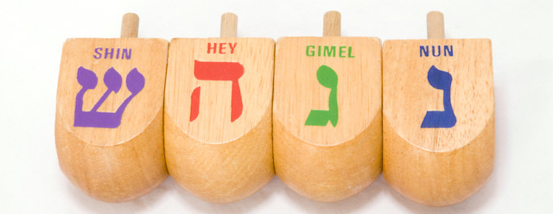
Hebrew is read from Left to Right
a) Nun means “nisht” or “nothing.” The player does nothing.
b) Gimel means “gantz” or “everything.” The player gets everything in the pot.
c) Hey means “halb” or “half.” The player gets half of the pot. (If there is an odd number of pieces in the pot, the player takes half of the total plus one).
d) Shin (outside of Israel) means “shtel” or “put in.” Peh (in Israel) also means “put in.” The player adds a game piece to the pot.
5. If you find that you have no game pieces left, you are either “out” or may ask a fellow player for a “loan.”
6. When one person has won everything, that round of the game is over!
Reprinted with permission from A Different Light: The Hanukkah Book of Celebration, published by the Shalom Hartman Institute and Devora Publishing.
These are the websites for pictures used in this document
https://www.google.bs/search?q=childrens+coloring+jesus+light+of+the+world&tbm=isch&tbo=u&source=univ&sa=X&ved=0ahUKEwj_guS40dDXAhVBVyYKHRItB80Q7AkINQ&biw=1366&bih=613
https://www.google.bs/search?biw=1366&bih=662&tbm=isch&sa=1&ei=CfAUWtGwFcGh_wSZ6q-QCg&q=childrens+coloring+hanukkah&oq=childrens+coloring+hanukkah&gs_l=psy-ab.3...16201.22588.0.23217.12.11.1.0.0.0.190.1301.0j10.10.0....0...1c.1.64.psy-ab..1.3.462...0j0i8i30k1.0.Vfm8-gYSZNY

https://www.google.bs/search?q=childrens+coloring+jesus+light+of+the+world&tbm=isch&tbo=u&source=univ&sa=X&ved=0ahUKEwj_guS40dDXAhVBVyYKHRItB80Q7AkINQ&biw=1366&bih=613

https://www.google.bs/search?tbm=isch&q=childrens+hanukia+pictures+to+colour&chips=q:childrens+hanukia+pictures+to+colour,online_chips:menorah+coloring,online_chips:dreidel+coloring,online_chips:knight&sa=X&ved=0ahUKEwiYgdPdz9DXAhWLJiYKHWcXANgQ4lYIKSgD&biw=1366&bih=613&dpr=1
Dreidel and Latkes - Potato pancakes
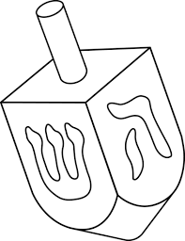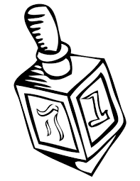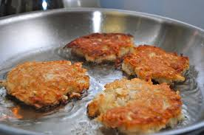

Websites for Hanukka

https://www.myjewishlearning.com/article/how-to-play-dreidel/

Recipes for Hanukkah
The ever-popular potato latke heads the list of traditional, oily Hanukkah treats.

HANUKKAH

How to Light the Hanukkah Menorah
The traditional blessings and procedures for lighting the Hanukkah candles.

HANUKKAH FOOD

How to Make Perfect Latkes for Hanukkah
Our video shows you exactly how to make them crispy and golden.
NOTE about BINGO game.
Ask students to identify the pictures on the Bingo Card and what they represent for Hannukka.
There are 3 differetly arranged BINGO cards so that too many students do not win at the same time.
Students can also make more cards by cutting them apart and aranging them in still another order.
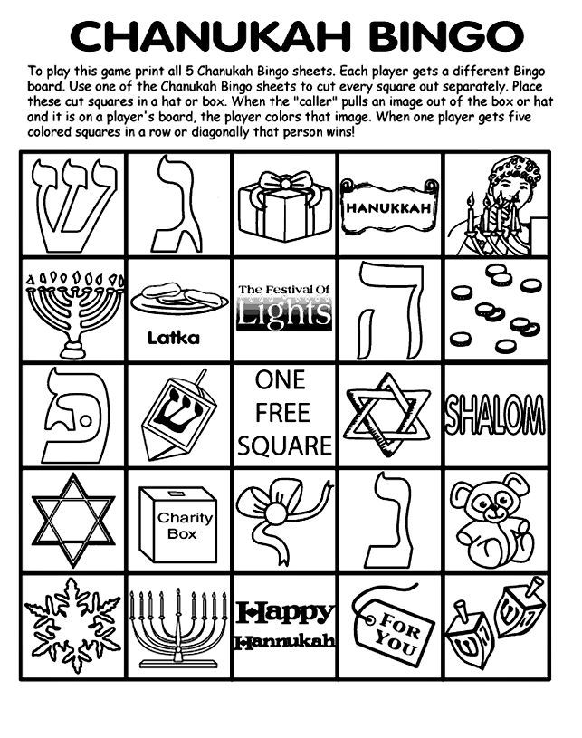
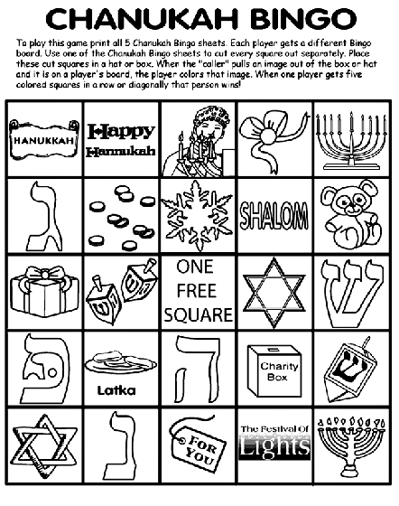
Figure 1https://www.google.bs/search?biw=1366&bih=662&tbm=isch&sa=1&ei=CfAUWtGwFcGh_wSZ6q-QCg&q=childrens+coloring+hanukkah&oq=childrens+coloring+hanukkah&gs_l=psy-ab.3...16201.22588.0.23217.12.11.1.0.0.0.190.1301.0j10.10.0....0...1c.1.64.psy-ab..1.3.462...0j0i8

