Contents

[Outline of Children and Teenagers in the Bible 2](#_Toc24909440)

[1. Introductory lesson: 4](#_Toc24909441)

[Cain & Abel 8](#_Toc24909442)

[Isaac 8](#_Toc24909443)

[Lineage 9](#_Toc24909444)

[Ishmael 10](#_Toc24909445)

[Esau 10](#_Toc24909446)

[Jacob 10](#_Toc24909447)

[Joseph 11](#_Toc24909448)

[Miriam 15](#_Toc24909449)

[Moses 18](#_Toc24909450)

[God worked through the life of Moses 32](#_Toc24909451)

[Moses – God’s Faithful Servant of God 34](file:///C:\Users\User\Documents\1%202019%20Cayman%20Islands\Children%20Teens%20in%20the%20Bible%20draft%20Nov%2017%202019.docx#_Toc24909452)

[Simulated Holy Land Tour through the Eyes of Moses and Joshua 35](#_Toc24909453)

[Joshua 39](#_Toc24909454)

[King Josiah 41](#_Toc24909455)

[King Jorash 41](#_Toc24909456)

[John the Baptist 41](#_Toc24909457)

[Jesus 42](#_Toc24909458)

[Jairus Daughter 62](#_Toc24909459)

[The Boy with the Loaves & Fishes 62](#_Toc24909460)

[Timothy 62](#_Toc24909461)

## Outline of Children and Teenagers in the Bible

1. Introduction:
2. Cain & Abel
3. Isaac
4. Ishmael
5. Esau
6. Jacob
7. Joseph
8. Benjamin
9. Moses
10. Joshua
11. Samuel
12. David
13. Solomon
14. Naaman’s Maiden
15. King Josiah
16. King Jorash
17. Jesus
18. Jairus Daughter
19. The boy with the Loaves & Fishes
20. Paul’s Nephew
21. Timothy
22. Add others

*Do you know that children and teens played a very important role in the Bible?*

*Who are the children and teens you already know about?*

*Are there some you would like to learn about?*

*You can create your own book of learning about some amazing and some not so amazing people; and learn about yourself…*

Think about it, some children and teenagerswe hear about briefly and possibly only one time; however, others we hear about from the time that they were born until when they died. Do you know that God chose each one for a certain purpose? Each child and teenager had a very important role to play and God used them to teach us a lesson or two. This will be true for you as well!

Some were servants, some were sons or daughters of important people, others were ordinary people, some were shepherds and still others were kings. Each one was important and each one had a story to tell and a lesson to learn from. Some of these people also learned some shocking lessons. What lessons might they have learned? Some might be older than you and others younger. In these lessons you will explore the details about their life and get to know them like a sister or brother, or like an uncle or aunt.

In this document lessons have been written to provide the information mentioned above and for you to learn all the things listed below. The lessons may be done with pictures, or by reading and answering questions, or like a drama or mime, or reader’s theatre. Have some fun with the stories, act them out for others, make a game of charades and have others guess who you are. Draw your own pictures; write up the story in your own words, colour pictures; but the most important thing is to look for what God wants you to learn from the person’s life, or an event. Take note that God describes some of these people in great detail, so much so that you feel you have gotten to know them very well. For Example: Moses is one of these amazing people. God gave him the most difficult job at the age of 80. Moses led the Children of Israel through the desert toward Canaan. Learn more about Moses in the books of Exodus, Leviticus, Numbers and Deuteronomy. God also inspired him to write the book of Genesis. He was an amazing man who spoke face to face with God….

**Get out your Bible, because you will need to learn about the following:**

Choose from the people below who you would like to learn about. Then answer the questions with help from your parents, brothers, sisters, aunts, uncles, neighbors, pastors or teachers. It is amazing to learn what God tells us about people. It is not always good that was done by the people. Read your Bible and get to know these people. If you have made a decision to follow Jesus as your Lord and personal Saviour, your name is written in the lambs book of life in heaven; and we may just meet them one day. We will know them by the spirit.

Names of many children and teens have been identified earlier, however, only a few of he lessons have been fleshed out.

A SPECIAL NOTE TO YOU:

Only a few of the lessons for the children and teens have been developed, so I invite you to either develop your own book of Children and Teens from the Bible. You will be blessed and you will learn so much for life.

**OR**

If you are inspired to help write these lessons and include them in this document, I invite you to do so, email them to me and I will include them in the document and credit you as author for your work.

Have fun. It is truly a journey of learning.

Helen Wall

## 1. Introductory lesson:

This lesson is an overview and gives a sample introduction to what you can learn. It also shows the times in the Bible in which they lived.

1. **Discuss:**

* Which people on the 3 pages do you already know about?
* What do you know about them?
* What is it that fascinates you about this story?
* Why do you remember this story?
* Would you like to learn more about each person?

1. This is what the lessons will do – challenge **you to learn more about God’s amazing people**.
2. Now **colour** the pictures to help you remember who they were and figure out in the sequence that they lived.
3. You can now make these pictures the beginning of **your book “Children and Teens in the Bible.**

**OR**

In the first example you can **tape the 3 pages together to make a small book** or 3 page leaflet or post on a wall or in your room at home to remember the people and how God used them to teach you important things. This will begin to give you a road map of some of the important Children and teens in the Bible.

* Children and teens in the Bible

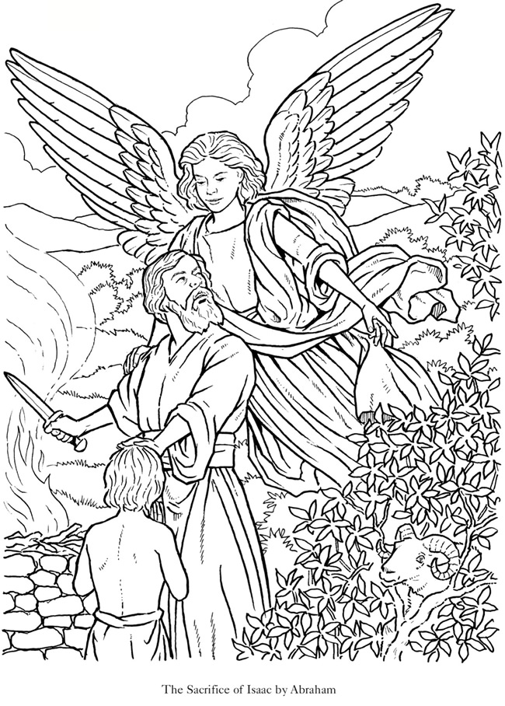

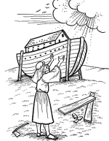

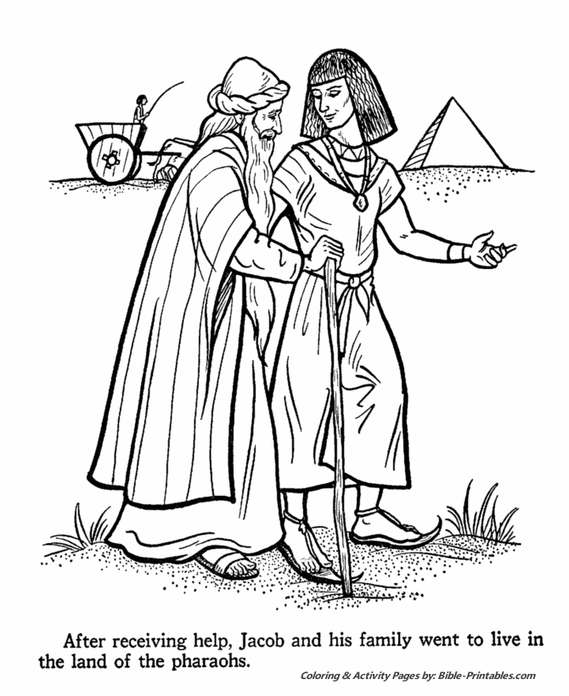

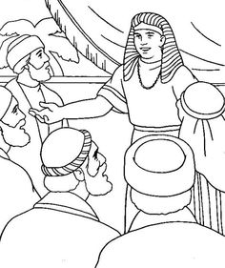



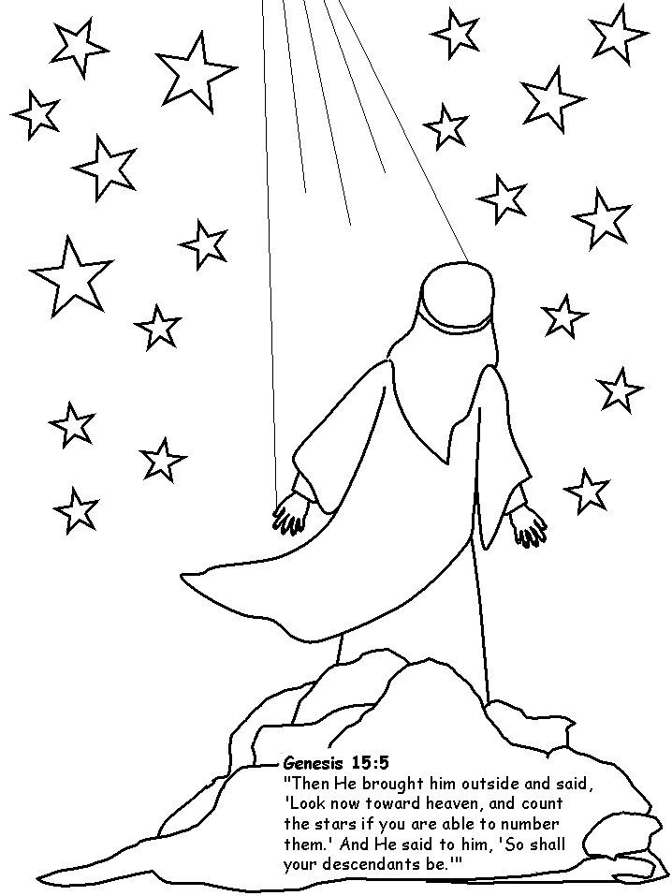

Southern Kingdom

*2 Tribes*

*Benjamin & Judah*

* Children and teens in the Bible

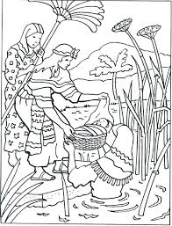

Northern Kingdom

*\*King Joash (7 Years old)*

*\*King Josiah (8 Years old)*

**Torah**

**Commandments**

**God’s Holy Days**

**Sabbath**

**Spring Feasts**

**Fall Feasts**

Jesus is from the tribe of Judah

* Children and teens in the Bible

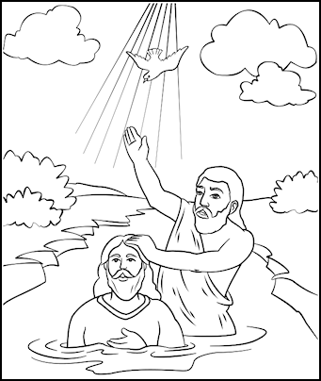

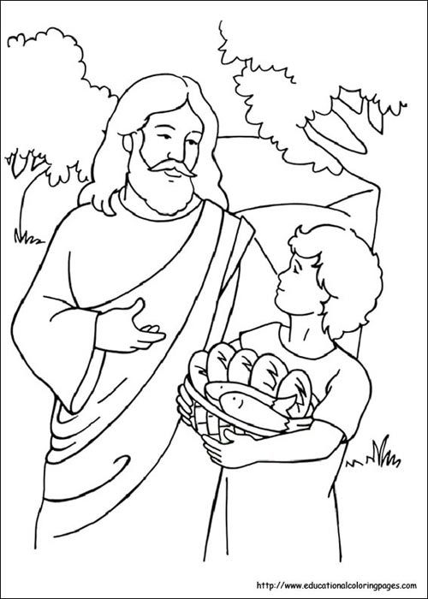

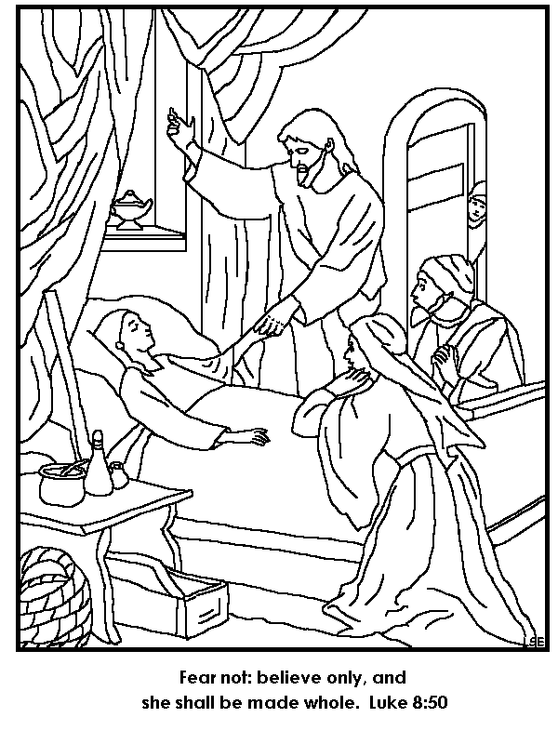

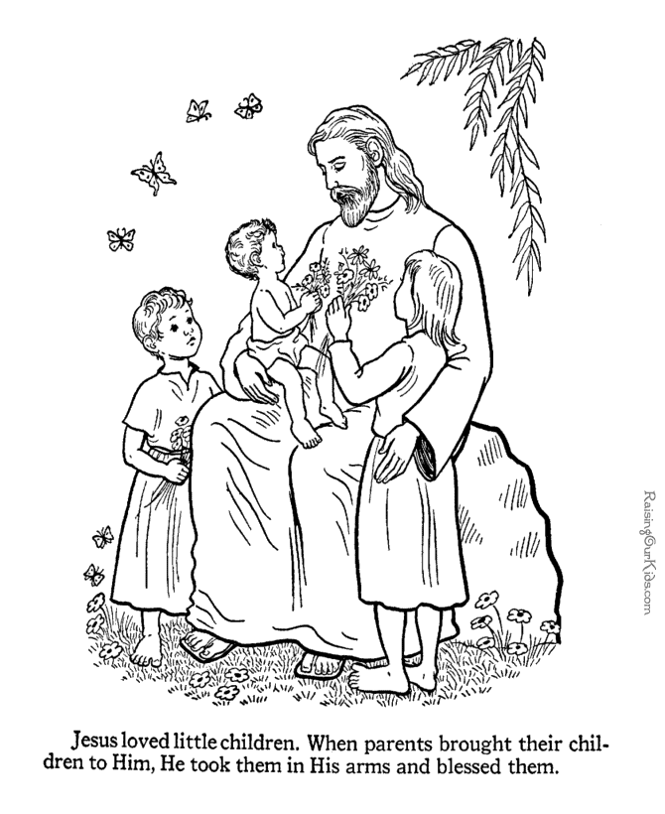

### Cain & Abel

* 1. When did the child/teenager live?
  2. Where did the child/teenager live?
  3. Who were the parents of this person?
  4. Did the person have relatives who were important people? Who were they?
  5. What did the child do that he or she was noticed? Why were they noticed?
  6. What lessons can we learn from the life of that child/teenager who may also have become an adult?
  7. If the child/teenager grew old, how did God use the individual? We are all created for a purpose.
  8. How can we apply what we have learned from the life of the person?
  9. Questions and Answers that apply to you, the learner?
  10. Who of these people would you chose to be like? Why?
  11. How would you have felt if you were that child/teenager in that situation
  12. Identify what you found interesting the child/teenager’s life.
  13. What might your purpose in life be?
  14. Do you know what you want to accomplish in life?
  15. Do you have dreams or aspirations in life already? How do they fit into God’s plan?

### Isaac

* 1. When did the child/teenager live?
  2. Where did the child/teenager live?
  3. Who were the parents of this person?
  4. Who were the parents of the child/teenager?
  5. Did the person have relatives who were important people? Who were they?
  6. What did the child do that he or she was noticed? Why were they noticed?
  7. What lessons can we learn from the life of that child/teenager who may also have become an adult?
  8. If the child/teenager grew old, how did God use the individual? We are all created for a purpose.
  9. How can we apply what we have learned from the life of the person?
  10. Questions and Answers that apply to you, the learner?
  11. Who of these people would you chose to be like? Why?
  12. How would you have felt if you were that child/teenager in that situation
  13. Identify what you found interesting the child/teenager’s life.
  14. What might your purpose in life be?
  15. Do you know what you want to accomplish in life?
  16. Do you have dreams or aspirations in life already? How do they fit into God’s plan?

### Lineage

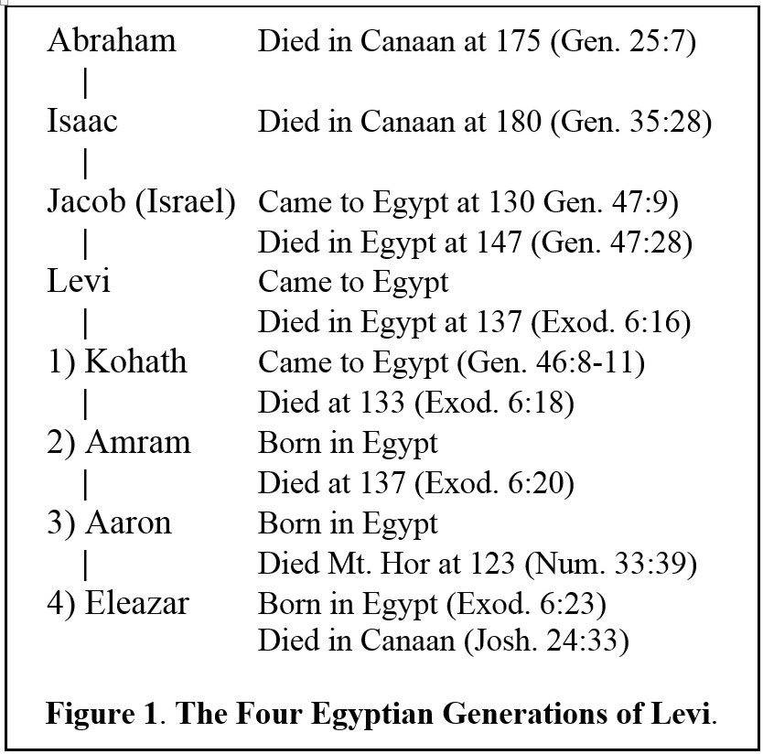

### Ishmael

* 1. When did the child/teenager live?
  2. Where did the child/teenager live?
  3. Who were the parents of this person?
  4. Did the person have relatives who were important people? Who were they?
  5. What did the child do that he or she was noticed? Why were they noticed?
  6. What lessons can we learn from the life of that child/teenager who may also have become an adult?
  7. If the child/teenager grew old, how did God use the individual? We are all created for a purpose.
  8. How can we apply what we have learned from the life of the person?
  9. Questions and Answers that apply to you, the learner?
  10. Who of these people would you chose to be like? Why?
  11. How would you have felt if you were that child/teenager in that situation
  12. Identify what you found interesting the child/teenager’s life.
  13. What might your purpose in life be?
  14. Do you know what you want to accomplish in life?
  15. Do you have dreams or aspirations in life already? How do they fit into God’s plan?

### Esau

### Jacob

### Joseph

1. When did the Joseph live?
2. Where did the child/teenager live?
3. Who were the parents of the child/teenager?
4. Did the person have relatives who were important people? Who were they?
5. What did the child do that he or she was noticed? Why were they noticed?
6. What lessons can we learn from the life of that child/teenager who may also have become an adult?
7. If the child/teenager grew old, how did God use the individual? We are all created for a purpose.
8. How can we apply what we have learned from the life of the person?
9. Questions and Answers that apply to you, the learner?
10. Who of these people would you chose to be like? Why?
11. How would you have felt if you were that child/teenager in that situation
12. Identify what you found interesting the child/teenager’s life.
13. What might your purpose in life be?
14. Do you know what you want to accomplish in life?
15. Do you have dreams or aspirations in life already? How do they fit into God’s plan?

|  |  |  |  |  |
| --- | --- | --- | --- | --- |
| 1.  2.  3.  4.  5.  6.  Genesis chapters 37, 38-50 | | | | |
| Click to see printable version of Jacob Giving Joseph the Coat of Many Colors Coloring page  Jacob gives Joseph the coat.  Why?. | Joseph's Dreams from Joseph son of Jacob  Joseph’s dream about sheaves bowing down to him and the dream about …  What did this foreshadow? … | | | Click to see printable version of Joseph is Sold into Slavery by His Brothers Coloring page  Joseph sold into slavery by his brothers for ……  Why? ..  What was God’s plan? … |
| Click to see printable version of Joseph's Bloody Coat Brought to Jacob Coloring page  Jacob responding to Joseph’s bloody coat. What had the brothers done?  Why?... | Click to see printable version of Joseph and Potiphar's Wife Coloring page  Joseph and Potiphar’s wife. What happens next? … | | | http://www.supercoloring.com/sites/default/files/styles/coloring_full/public/cif/2013/08/3-joseph-in-prison-coloring-page.jpg  Joseph in Prison. Whose dreams does he interpret?....  What happens next? … |
| Joseph Interpreting the Pharaoh's Dream from Joseph son of Jacob  7.  Joseph interpreting Pharaoh’s dream. What was it?... | | Joseph Overseer of Pharaoh's Granaries from Misc. Artists  8.  Joseph oversees Pharaoh’s granaries. Why? …  What happens next? … | Click to see printable version of Joseph Forgives His Brothers Coloring page  9.  Joseph hugs his brothers and forgives them.. Why? ……………………..  What happens next? ……………….. | |
| http://www.supercoloring.com/sites/default/files/styles/coloring_full/public/cif/2013/09/joseph-meet-jacob-coloring-page.jpg  10.  Joseph meets Jacob in Goshen, Egypt. Why? ... | | God’s plans:  God’s provisions: | What lessons can we learn for life from this story? | |
| **Memory Verse:**  **Genesis 50:20**  Yes, you yourselves planned evil against me. God planned it for good, in order to bring about what it is this day—to preserve the lives of many people. | | |

### Benjamin

1. When did Benjamin live?
2. Where did Benjamin live?
3. Who were the parents of Benjamin? What happened to his mother?
4. Did the person have relatives who were important people? Who were they?
5. What did the child do that he or she was noticed? Why were they noticed?
6. What lessons can we learn from the life of that child/teenager who may also have become an adult?
7. If the child/teenager grew old, how did God use the individual? We are all created for a purpose.
8. How can we apply what we have learned from the life of the person?
9. Questions and Answers that apply to you, the learner?
10. Who of these people would you chose to be like? Why?
11. How would you have felt if you were that child/teenager in that situation
12. Identify what you found interesting the child/teenager’s life.
13. What might your purpose in life be?
14. Do you know what you want to accomplish in life?
15. Do you have dreams or aspirations in life already? How do they fit into God’s plan?

### Miriam

1. When did the Miriam live?
2. Where did Miriam live?
3. Who were the parents of the child/teenager?
4. Did Miriam have relatives who were important people? Who were they?
5. What Miriam do that he or she was noticed? Why were they noticed?
6. What lessons can we learn from the life of Miriam?
7. If Miriam, how did God use the individual? We are all created for a purpose.
8. How can we apply what we have learned from the life of Miriam?
9. Questions and Answers that apply to you, the learner?
10. Who of these people would you chose to be like? Why?
11. How would you have felt if you were Miriam in that situation?
12. Identify what you found interesting Miriam’s life.
13. What might your purpose in life be?
14. Do you know what you want to accomplish in life?
15. Do you have dreams or aspirations in life already? How do they fit into God’s plan?

|  |  |  |
| --- | --- | --- |
| Moses found by Pharaoh's daughter in a basket among the reeds. Bible coloring page  Exodus 2:3 she (Miriam’s mother) took an ark of bulrushes for him, daubed it with asphalt and pitch, put the child in it, and laid *it* in the reeds by the river’s bank.  **5**Then the daughter of Pharaoh came down to bathe at the river. And her maidens walked along the riverside; and when she saw the ark among the reeds, she sent her maid to get it. **6**And when she opened *it,* she saw the child, and behold, the baby wept. So she had compassion on him, and said, “This is one of the Hebrews’ children.” …  **10**And the child grew, and she brought him to Pharaoh’s daughter, and he became her son.  So she called his name Moses …  1.  2.  3.  4.  5.  6.  http://www.supercoloring.com/sites/default/files/styles/coloring_full/public/cif/2013/09/59-miriam-and-baby-moses-delaroche-coloring-page.jpg | **4**And his sister stood afar off, to know what would be done to him. | Click to see printable version of Finding of Moses Coloring page |
| Exodus 2: Moses lived in the Pharaoh’s  Palace for 40 years. Then one day he saw a Hebrew being beaten by an Egyptian. **12**So he looked this way and that way, and when he saw no one, he killed the Egyptian and hid him in the sand. **13**And when he went out the second day, behold, two Hebrew men were fighting, and he said to the one who did the wrong, “Why are you striking your companion?” **14**Then he said, “Who made you a prince and a judge over us? Do you intend to kill me as you killed the Egyptian?”  Moses fled to Midian and lived there 40 years until God called him to return to Egypt because he had work for him to do. What was that work? | Israelites Crossing the Red Sea from Exodus  Moses led the children out of Egypt into the wilderness and across the Red Sea. | Miriam Celebrates the Crossing of Red Sea from Exodus  After the Israelites had crossed the Red Sea, Miriam danced and sang the song of Moses. |
| **15**So **Miriam** was shut out of the camp seven days, and the people did not journey till **Miriam** was brought in *again.* [Numbers 20:1](https://www.biblegateway.com/passage/?search=Numbers+20:1&version=NKJV) Then the children of Israel, the whole congregation, came into the Wilderness of Zin in the first month, and the people stayed in Kadesh; and **Miriam** died there and was buried there.  7.  8.  9.  Memory Verse:3And they are singing the song of Moses the servant of God and the song of the Lamb, saying, “Great and wonderful are Your deeds, Adonai Elohei-Tzva’to. Just and true are Your ways, O King of the nations!Revelation 15:3 Tree of Life Version (TLV)  Click to see printable version of Miriam Dancing  Coloring page  **Exodus 15:19, -21**[ *The Song of****Miriam*** ]  For Pharaoh’s horses with his chariots and his horsemen went into the sea, but ADONAI brought the waters of the sea back over them. Yet *Bnei-Yisrael* walked in the midst of the sea on dry ground. **20**Then Miriam the prophetess, Aaron’s sister, took a tambourine in her hand, and all the women went out after her with tambourines and with dancing, **21**as Miriam sang to them: Sing to *Adonai*, for He is highly exalted! The horse and its rider He has thrown into the sea! | [Numbers 12](https://www.biblegateway.com/passage/?search=Numbers+12&version=NKJV)  [*Dissension of Aaron and Miriam]*  Then **Miriam** and Aaron spoke against Moses because of the Ethiopian woman whom he had married; for he had married an Ethiopian woman. So they said, “Has the Lord indeed spoken only through Moses? Has He not spoken through us also?” And the Lord heard *it.* (Now the man Moses *was* very humble, more than all men who *were* on the face of the earth.) ...  [Numbers 12](https://www.biblegateway.com/passage/?search=Numbers+12:4&version=NKJV) **4**Suddenly the Lord said to Moses, Aaron, and **Miriam**, “Come out, you three, to the tabernacle of meeting!” So the three came out. **5**Then the Lord came down in the pillar of cloud and stood *in* the door of the tabernacle, and called Aaron and Miriam. And they both went forward… **10**And when the cloud departed from above the tabernacle, suddenly Miriam became leprous, as white as snow. Then Aaron turned toward **Miriam**, and there she was, a leper…. | Image result for christian coloring book pictures aaron |

<https://www.pinterest.ca/pin/549298485789943185/?lp=true>

<http://www.supercoloring.com/pages/miriam-dancing>

### Moses

#### Study of Moses

#### Readers Theatre or Mime

**NOTE:** This will be simplified as the story is told, rather than read. The scripture is a reference and reminders of what should be said. The text is taken directly from the Bible.

***When we do the mini production in class characters are in costume and do mime as the narrator reads or tells the story. At various times the voice of God will be heard.***

***The teacher helpers can coach the children by showing them some of the emotions in order to make the story more real. The coaches would be facing the students who are in costume and show them some of the emotions... The other students are watching the production.***

**We need these characters:**

1. Moses,
2. Aaron, Aaron and Hur to hold up Moses’ arm in the battle of the Amalekites
3. Pharaoh
4. Miriam
5. Pharaoh's daughter and assistant
6. Joshua
7. Caleb
8. Balaam, Balak & a donkey
9. Reader of the 10 commandments and everyone repeats after each commandment is read.
10. Reader of the miracles during the journey.
11. The Israelites
12. **Voice of God**
13. ***✡* Someone to ring a bell when a miracle is mentioned.**

**Props for the story**

1. A quart jar to show how much manna was gathered each day and 2 for the Sabbath
2. Basket for Moses as a baby, some greenery, etc
3. Staff for Moses and his costume
4. Costume for Aaron
5. Clothes for Pharaoh
6. Pharaoh's daughter's clothes
7. Joshua costume - Battle of Amalekites – Moses, Aaron and Hur
8. Aaron's costume
9. Miriam’s clothes and has tambourine
10. Tablets of Stone for Moses
11. Stick for carrying the grapes
12. Burning bush ....
13. Balaam’s donkey
14. Balak – King of Moab
15. Camera ?

**NOTE:**

**NARRATOR: will read some of the scripture, but summarize other parts to keep the story simple and moving more quickly.**

**Voice of God: designate someone to read the text in red as the voice of God.**

Some children may have 2 roles if there are only a few. If there are many then the other children will be the children of Israel as a group.

***✡*** **Miracle**

**A question to ask throughout is: how did Moses feel when these things happened?**

**How did God feel and what did he do at various times?**

**Story of Moses**

**NARRATOR: Tells parts of the story and read’s some verses from the Bible for detail and to remind students that this is God’s Story about the Israelites in the wilderness and their journey.**

1. **Moses** and Miriam at the river
   1. Miriam is watching baby Moses who is in the basket on the Nile River. He is now 3 months old or a little older because his mother could no longer hide him in the home.
   2. Who comes to bathe at the river?
2. Pharaoh's daughter goes to the river.
   1. She admires the beautiful baby and says Oh – he is a beautiful Hebrew child.
   2. She makes arrangements with Moses mother to adopt Moses and come to be her child and live with her in the palace.
3. Moses goes to live in pharaoh's palace for 40 years. [Exodus 2:10](https://www.biblegateway.com/passage/?search=Exodus+2:10&version=TLB)

Later, when he was older, she brought him back to the princess and he became her son. She named him **Moses** (meaning “to draw out”) because she had drawn him out of the water.

1. Moses went to school in pharaoh's palace
2. Egyptian is killed: Exodus 2:12, 13 One day, many years later when **Moses** had grown up and become a man, he went out to visit his fellow Hebrews and saw the terrible conditions they were under. During his visit he saw an Egyptian knock a Hebrew to the ground—one of his own Hebrew brothers! **Moses** looked this way and that to be sure no one was watching, then killed the Egyptian and hid his body in the sand.
3. **Moses** walks through the desert, is a shepherd in Midian
   1. In Midian he married an Ethiopian wife and had 2 sons
4. **Voice of God** speaks to Moses in the burning bush. Moses makes excuses that he is not able to do the job - thick tongue and slow to speak
   1. ***✡Moses****at the* ***Burning Bush*** ] Now **Moses** was tending the flock of Jethro his father-in-law, the priest of Midian. And he led the flock to the back of the desert, and came to Horeb, the mountain of God. And the Angel of the Lord appeared to him in a flame of fire from the midst of a bush. So he looked, and behold, the bush was burning with fire, but the bush *was* not consumed. Then **Moses** said, “I will now turn aside and see this great sight, why the bush does not burn.”
   2. **4**So when the Lord saw that he turned aside to look, God called to him from the midst of the bush and said, “Moses, Moses!”
   3. And **Moses** said, “Here I am.”
   4. **5**Then God said, “Do not draw near this place. Take your sandals off your feet, for the place where you stand *is* holy ground.” **6**… “I *am* the God of your father—the God of Abraham, the God of Isaac, and the God of Jacob.” **And Moses hid his face, for he was afraid to look upon God.**
   5. Take your sandals off your feet, for the place where you are standing is holy ground.”…
   6. I have heard their cry of the Israelites because of their slave masters, for I know their pains. **8**So I have come down to deliver them out of the hand of the Egyptians, to bring them up out of that land into a good and large land, a land flowing with milk and honey …  **10Come now, I will send you to Pharaoh, so that you may bring My people out from Egypt.”**
   7. **11**But **Moses** said to God, “Who am I, that I should go to Pharaoh, and bring *Bnei-Yisrael* out of Egypt?”
   8. **12**So He said, “I will surely be with you. So that will be the sign to you that it is I who have sent you. When you have brought the people out of Egypt: you will worship God on this mountain.”
   9. **13**But **Moses** said to God, “Suppose I go to *the children of Israel* and say to them, ‘The God of your fathers has sent me to you,’ and they ask me, ‘What is His Name?’ What should I say to them?”
   10. **God gives** **Moses** instructions: My name is “I AM WHO I AM.” This is my name forever. **18**“They will listen to your voice. So you will go, you along with the elders of Israel, to the king of Egypt, and say to him: the God of the Hebrews, has met with us. Now please let us take a three-day journey into the wilderness, so that we may sacrifice to *Adonai* our God.’ **19**Nevertheless, I know that the king of Egypt will not let you go, except by a mighty hand. **20**So I will stretch out My hand and strike Egypt with all My wonders that I will do in the midst of it. After that, he will let you go.
   11. **Moses** pleads with God “I do not want to go because “I speak slowly and have heavy tongue.” ….**12**
   12. **God says:** Now go! I will be with your mouth and teach you what to say.”
   13. But Moses argued with the Lord, saying, “I can’t do it! I’m such a clumsy speaker! Why should Pharaoh listen to me?”
   14. **Moses** asks God to send anyone else … God agrees to send Aaron along with Moses since he is able to speak well.
   15. **God** says:✡ “*And look! He is on his way to meet you now.* He will be delighted to see you. **15**Talk to him, and put the words in his mouth. I will be with both of you as you speak, and I will instruct you both in what to do. **16**Aaron will be your spokesman to the people. He will be your mouthpiece, and you will stand in the place of God for him, telling him what to say. **17**And take your shepherd’s staff with you, and use it to perform the miraculous signs I have shown you.”
5. ***Moses and Aaron*** are now in Egypt and are talking to Pharaoh.
   1. *Moses and Aaron* spoke to Israel’s leaders, they went and spoke to Pharaoh. They told him, “This is what the Lord, the God of Israel, says: Let my people go so they may hold a festival in my honor in the wilderness.”
   2. **2**“Is that so?” retorted **Pharaoh**. “And who is the Lord? Why should I listen to him and let Israel go? I don’t know the Lord, and I will not let Israel go.”
   3. **3**But *Aaron and Moses* persisted. “The God of the Hebrews has met with us,” “So let us take a three-day journey into the wilderness so we can offer sacrifices to the Lord our God. If we don’t, he will kill us with a plague or with the sword.”
   4. **4Pharaoh replied**, “Moses and Aaron, why are you distracting the people from their tasks? Get back to work! **5**Look, there are many of your people in the land, and you are stopping them from their work.”
6. ✡**Pharaoh** and plagues (pharaoh illustrates them with actions) **(all the children can respond as the Egyptians would with --- oooo – no ---ugg---- yuk… etc.)**

[**Blood: Ex. 7:14–24**](https://en.wikipedia.org/wiki/Plagues_of_Egypt#1._Blood:_Ex._7:14%E2%80%9324)

[**Frogs: Ex. 7:25–8:15**](https://en.wikipedia.org/wiki/Plagues_of_Egypt#2._Frogs:_Ex._7:25%E2%80%938:15)

[**Lice or Gnats: Ex. 8:16-19**](https://en.wikipedia.org/wiki/Plagues_of_Egypt#3._Lice_or_Gnats:_Ex._8:16-19)

[**Flies: Ex. 8:20-32**](https://en.wikipedia.org/wiki/Plagues_of_Egypt#4._Wild_animals_or_flies:_Ex._8:20-32)

[**Pestilence of livestock: Ex. 9:1–7**](https://en.wikipedia.org/wiki/Plagues_of_Egypt#5._Pestilence_of_livestock:_Ex._9:1%E2%80%937)

[**Boils: Ex. 9:8–12**](https://en.wikipedia.org/wiki/Plagues_of_Egypt#6._Boils:_Ex._9:8%E2%80%9312)

[**Thunderstorm of hail, rain and fire: Ex. 9:13–35**](https://en.wikipedia.org/wiki/Plagues_of_Egypt#7._Thunderstorm_of_hail_and_fire:_Ex._9:13%E2%80%9335)

[**Locusts: Ex. 10:1–20**](https://en.wikipedia.org/wiki/Plagues_of_Egypt#8._Locusts:_Ex._10:1%E2%80%9320)

[**Darkness for three days: Ex. 10:21–29**](https://en.wikipedia.org/wiki/Plagues_of_Egypt#9._Darkness_for_three_days:_Ex._10:21%E2%80%9329)

[**Death of firstborn: Ex. 11:1–12:36**](https://en.wikipedia.org/wiki/Plagues_of_Egypt#10._Death_of_firstborn:_Ex._11:1%E2%80%9312:36)

1. **Moses** gives instructions to the Israelites. --- about the Passover, packing up and leaving Goshen for the wilderness journey. They will eat all the lamb and leave at dawn.
   1. When you go, you will not leave empty-handed. **22**Every woman is to ask her neighbor and the woman who lives in her house for silver and gold jewelry and clothing. You will put them on your sons and your daughters. So you will plunder the Egyptians.”
   2. Eating before leaving:
      * That same night they must roast the meat over a fire and eat it along with bitter salad greens and bread made without yeast.  **10**Do not leave any of it until the next morning. Burn whatever is not eaten before morning.
      * **11**“… eat the meal quickly: Be fully dressed,[[a](https://www.biblegateway.com/passage/?search=Exodus+12&version=NKJV;NLT" \l "fen-NLT-1828a" \o "See footnote a)] wear your sandals, and carry your walking stick in your hand. Eat the meal with urgency, for this is the Lord’s Passover. **12**On that night I will pass through the land of Egypt and strike down every firstborn son and firstborn male animal in the land of Egypt. I will execute judgment against all the gods of Egypt, for I am the Lord! **13**The blood on your doorposts will serve as a sign, marking the houses where you are staying. ✡When I see the blood, I will pass over you. This plague of death will not touch you when I strike the land of Egypt.
      * **14**“This is a day to remember. Each year, from generation to generation, you must celebrate it as a special festival to the Lord. This is a law for all time.

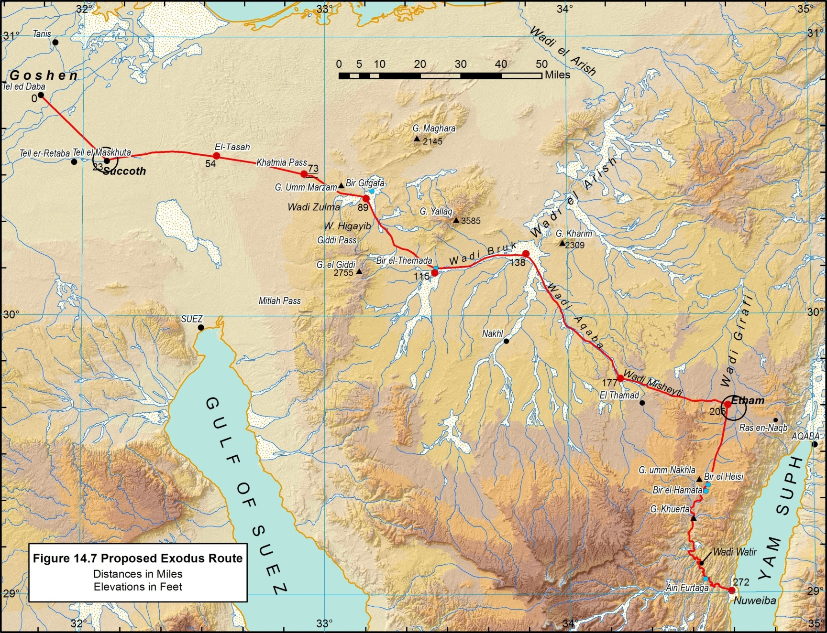

<https://ancientexodus.com/map-of-the-exodus-from-egypt/>



1. **31Pharaoh sent for Moses and Aaron** during the night. “Get out!” he ordered. “Leave my people—and take the rest of the Israelites with you! Go and worship the Lord as you have requested. **32**Take your flocks and herds, as you said, and be gone. Go, but bless me as you leave.” **33**All the Egyptians urged the people of Israel to get out of the land as quickly as possible, for they thought, “We will all die!”
   1. **34**The *Israelites* took their bread dough before yeast was added. They wrapped their kneading boards in their cloaks and carried them on their shoulders. **35**And the people of Israel did as Moses had instructed; they asked the Egyptians for clothing and articles of silver and gold.
   2. 600,000 men,[[b](https://www.biblegateway.com/passage/?search=Exodus+12&version=NKJV;NLT" \l "fen-NLT-1854b" \o "See footnote b)] plus all the women and children. **38**A rabble of non-Israelites went with them, along with great flocks and herds of livestock. **39**For bread they baked flat cakes from the dough without yeast they had brought from Egypt. It was made without yeast because the people were driven out of Egypt in such a hurry that they had no time to prepare the bread or other food.
   3. **40**The people of Israel had lived **in Egypt[**[**c**](https://www.biblegateway.com/passage/?search=Exodus+12&version=NKJV;NLT#fen-NLT-1857c)**] for 430 years**. **41**In fact, it was on the last day of the 430th year that all the Lord’s forces left the land. **42**On this night the Lord kept his promise to bring his people out of the land of Egypt. So this night belongs to him, and it must be commemorated every year by all the Israelites, from generation to generation. **Exodus 12:40**
2. Walking in the desert for 3 months until they reach Mt. Sinai.
   1. ✡Exodus 19:1 On the first day of the third month after the Israelites left Egypt—on that very day—they came to the Desert of Sinai. **2**After they set out from Rephidim, they entered the Desert of Sinai, and Israel camped there in the desert in front of the mountain.
3. ✡ They had already crossed the Red Sea during this time.
4. **Miriam** dances the Song of Moses
   1. Then Miriam the prophetess, the sister of Aaron, took a tambourine and led the women in dances.
   2. And **Miriam sang the song of Moses**: “Sing to the Lord, for he has triumphed gloriously. The horse and rider have been drowned in the sea.” *(Check YouTube for various versions, - play and sing it.)*

**Exodus 16. The Waters of Marah and Elim**

**22**Then Moses led Israel from the Red Sea and they went into the Desert of Shur. For three days they traveled in the desert without finding water. **23**When they came to Marah, they could not drink its water because it was bitter. (That is why the place is called Marah.[[f](https://www.biblegateway.com/passage/?search=Exodus+15&version=NIV" \l "fen-NIV-1944f" \o "See footnote f)]) **24**So the people grumbled against Moses, saying, “What are we to drink?”

**25**Then Moses cried out to the Lord, and the Lord showed him a piece of wood. He threw it into the water, and the water became fit to drink.

There the Lord issued a ruling and instruction for them and put them to the test. **26**He said, “If you listen carefully to the Lord your God and do what is right in his eyes, if you pay attention to his commands and keep all his decrees, I will not bring on you any of the diseases I brought on the Egyptians, for I am the Lord, who heals you.”

**27**Then they came to Elim, where there were twelve springs and seventy palm trees, and they camped there near the water.

✡**Water From the Rock**

**Exodus17**The whole Israelite community set out from the Desert of Sin, traveling from place to place as the Lord commanded. They camped at Rephidim, but there was no water for the people to drink. **2**So they quarreled with Moses and said, “Give us water to drink.”

Moses replied, “Why do you quarrel with me? Why do you put the Lord to the test?”

**3**But the people were thirsty for water there, and they grumbled against Moses. They said, “Why did you bring us up out of Egypt to make us and our children and livestock die of thirst?”

**4**Then Moses cried out to the Lord, “What am I to do with these people? They are almost ready to stone me.”

**5**The Lord answered Moses, “Go out in front of the people. Take with you some of the elders of Israel and take in your hand the staff with which you struck the Nile, and go. **6**I will stand there before you by the rock at Horeb. Strike the rock, and water will come out of it for the people to drink.” So Moses did this in the sight of the elders of Israel. **7**And he called the place Massah[[a](https://www.biblegateway.com/passage/?search=Exodus+17&version=NIV#fen-NIV-1991a)] and Meribah[[b](https://www.biblegateway.com/passage/?search=Exodus+17&version=NIV#fen-NIV-1991b)] because the Israelites quarreled and because they tested the Lord saying, “Is the Lord among us or not?”

1. ✡ Battle of the Amalekites. Joshua leads the army and when Moses holds his hands up the Israelites are winning the battle. When Moses' arms are tired and they go down, they are losing the battle. Aaron and Hur hold up Moses arms.

**The Amalekites Defeated**

**8**The Amalekites came and attacked the Israelites at Rephidim. **9**Moses said to Joshua, “Choose some of our men and go out to fight the Amalekites. Tomorrow I will stand on top of the hill with the staff of God in my hands.”

**10**So Joshua fought the Amalekites as Moses had ordered, and Moses, Aaron and Hur went to the top of the hill. **11**As long as Moses held up his hands, the Israelites were winning, but whenever he lowered his hands, the Amalekites were winning. **12**When Moses’ hands grew tired, they took a stone and put it under him and he sat on it. **Aaron and Hur held his hands up—one on one side, one on the other—so that his hands remained steady till sunset. 13So Joshua overcame the Amalekite army with the sword.**

**14**Then the Lord said to Moses, “Write this on a scroll as something to be remembered and make sure that Joshua hears it, because I will completely blot out the name of Amalek from under heaven.”

**15**Moses built an altar and called it The Lord is my Banner. **16**He said, “Because hands were lifted up against[[c](https://www.biblegateway.com/passage/?search=Exodus+17&version=NIV#fen-NIV-2000c)] the throne of the Lord,[[d](https://www.biblegateway.com/passage/?search=Exodus+17&version=NIV" \l "fen-NIV-2000d" \o "See footnote d)] the Lord will be at war against the Amalekites from generation to generation.”

1. ✡**God provides manna every day for 40 years.** They gathered 1 quart a day and 2 quarts before the Sabbath. They begged God for different food and requested meat. God sent them quail once. There was so much that it went rotten. God gave them bread from heaven when they were hungry and water from the rock when they were thirsty.
   1. the Lord says, ✡ **“During the forty years that I led you through the wilderness**, **your clothes did not wear out, nor did the sandals on your feet... I did this so that you might know that I am the Lord your God.”**

**At Mount Sinai**

**Exodus 19**On the first day of the third month after the Israelites left Egypt—on that very day—they came to the Desert of Sinai. **2**After they set out from Rephidim, they entered the Desert of Sinai, and Israel camped there in the desert in front of the mountain.

1. ✡**Voice of God and the thundering from the mountain**

Exodus 20 And Moses went up to God, and the Lord called to him from the mountain, saying, “Thus you shall say to the house of Jacob, and tell the children of Israel: **4**‘You have seen what I did to the Egyptians, and *how* I [[a](https://www.biblegateway.com/passage/?search=Exodus+19&version=NKJV#fen-NKJV-2031a)]bore you on eagles’ wings and brought you to Myself. Exodus 19:3 **9**And the Lord said to Moses, “Behold, I come to you in the thick cloud, that the people may hear when I speak with you, and believe you forever.”

**14**So Moses went down from the mountain to the people and sanctified the people, and they washed their clothes. **15**And he said to the people, “Be ready for the third day; …

**16**Then it came to pass on the third day, in the morning, that **there was thundering and lightening, and a thick cloud on the mountain; and the sound of the trumpet was very loud, so that all the people who *were* in the camp trembled. 17**And Moses brought the people out of the camp to meet with God, and they stood at the foot of the mountain. **18**Now Mount Sinai *was* completely in smoke, because the Lord descended upon it in fire. Its smoke ascended like the smoke of a furnace, and [[c](https://www.biblegateway.com/passage/?search=Exodus+19&version=NKJV#fen-NKJV-2045c)]the whole mountain quaked greatly. **19**And when the blast of the trumpet sounded long and became louder and louder, Moses spoke, and God answered him by voice. **20**Then the Lord came down upon Mount Sinai, on the top of the mountain. And the Lord called Moses to the top of the mountain, and Moses went up.

1. Moses climbs Mount Sinai **– How many times?**
   1. Moses turned and went down the mountain with the two tablets of the covenant law in his hands. They were inscribed on both sides, front and back. **16**The tablets were the work of God; the writing was the writing of God, engraved on the tablets.
   2. Moses goes up and down the mountain to tell the Israelite to stay away from them mountain
   3. Moses goes back up the mountain
   4. ✡**Voice of God**

Then the Lord said to Moses, “Go down, because your people, whom you brought up out of Egypt, have become corrupt. **8**They have been quick to turn away from what I commanded them and have made themselves an idol cast in the shape of a calf. They have bowed down to it and sacrificed to it and have said, ‘These are your gods, Israel, who brought you up out of Egypt.’

**9**“I have seen these people,” the Lord said to Moses, “and they are a stiff-necked people. **10**Now leave me alone so that my anger may burn against them and that I may destroy them. Then I will make you into a great nation.”

* 1. Exodus 32: 7-10

Moses sees the Israelites dancing around the golden calf they had built. He breaks the tablets with the 10 commandments. 3000 people die of a plague for being disobedient.

1. God tells Moses to make 2 tablets of stone for the commandments
   * 1. Moses goes back up the mountain with the tablets. God writes the commandments again.
     2. Moses brings down the tablets and teaches the people the commandments. Moses was up on the mountain for 40 days and 40 nights without eating.
2. **Exodus 34 - Reader** reads the 10 commandments.
3. Moses builds an amazing tabernacle that God gave instructions for them to build for him. They celebrate Passover.
4. Numbers 12: At Kadesh, **Miriam**, a prophetess, **and Aaron challenge Moses** about marrying an Ethiopian woman. Miriam develops leprosy and must leave the camp for 7 days. Miriam returns to the camp after 7 days and then dies at Kadesh
5. Numbers 13 --- **Spies go to Hebron** to check out the land of Canaan. 10 report Giants. Joshua and Caleb have a good report and are allowed to go into the land of Canaan.
   1. **Voice of God ----** The Lord replied, “I have forgiven them, as you asked. **21**Nevertheless, …  **22**not one of those who saw my glory and the signs I performed in Egypt and in the wilderness but who disobeyed me and tested me ten times— **23**not one of them will ever see the land I promised … to their ancestors. … **24**But because my servant Caleb has a different spirit and follows me wholeheartedly, I will bring him into the land he went to, and his descendants will inherit it.
      1. Consequence of not trusting God. All of the Israelites over the age of 20 are not allowed to go into Canaan and they would in the desert for 40 years because they didn't want to go into the land with the Giants. They rebelled. They did not have the faith that God would help them conquer the Giants.
6. **Numbers 20: 1 - 13** --- Moses gets in trouble by hitting the rock instead of speaking to it.
   1. ✡Voice of God when Moses hit the rock Take the staff and gather the assembly, you and your brother Aaron. Speak to the rock before their eyes, and it will give out its water. You will bring out water from the rock, and you will give the community something to drink, along with their livestock.”
   2. He and Aaron gathered the assembly together in front of the **rock** and Moses said to them, “Listen, you rebels, must we bring you water out of this **rock**?”
   3. Then Moses raised his arm and struck the **rock** twice with his staff. Water gushed out, and the community and their livestock drank.
7. ✡Moses talks to God and says you led them through the great and terrible wilderness—fiery serpents and scorpions, and thirsty ground where there was no water. God brought forth water for you from the flinty rock. Deuteronomy 8:15.
8. Aaron dies at Mount Hor at the age of 120. (Numbers 20: 22-29 )

**Balaam’s Donkey -** (the donkey who talks)

* 1. Numbers 22:2-41 in Moab –
  2. Numbers 22:2 **Voice of God**: But God said to Balaam, **“Do not go with them. You must not put a curse on those people, because they are blessed.”**

**Balak, king of Moab**, hires Balaam to curse Israel. The king of Moab was afraid of the Israelites camped in the plains of Moab and hires Balaam to put a curse on Israel.**21**Balaam got up in the morning, saddled his donkey and went with the Moabite officials. **22**But God was very angry when he went, and the angel of the Lord stood in the road to oppose him. Balaam was riding on his donkey, and his two servants were with him. **23**When the donkey saw the angel of the Lord standing in the road with a drawn sword in his hand, it turned off the road into a field. Balaam beat it to get it back on the road.

**24**Then the angel of the Lord stood in a narrow path through the vineyards, with walls on both sides. **25**When the donkey saw the angel of the Lord, it pressed close to the wall, crushing Balaam’s foot against it. So he beat the donkey again.

**26**Then the angel of the Lord moved on ahead and stood in a narrow place where there was no room to turn, either to the right or to the left. **27**When the donkey saw the angel of the Lord, it lay down under Balaam, and he was angry and beat it with his staff. **28Then the Lord opened the donkey’s mouth**, and it said to Balaam, **“What have I done to you to make you beat me these three times?”**

**29Balaam answered the donkey**, **“You have made a fool of me! If only I had a sword in my hand, I would kill you right now.”**

**30**The **donkey** said to Balaam, **“Am I not your own donkey, which you have always ridden, to this day? Have I been in the habit of doing this to you?”**

**“No,”** he (Balaam the king) said.

**31**Then the Lord opened Balaam’s eyes, and he saw the angel of the Lord standing in the road with his sword drawn. So he bowed low and fell facedown.

**32The angel of the Lord asked him,** “Why have you beaten your donkey these three times? I have come here to oppose you because your path is a reckless one before me.[[a](https://www.biblegateway.com/passage/?search=Numbers+22&version=NIV" \l "fen-NIV-4408a" \o "See footnote a)] **33**The donkey saw me and turned away from me these three times. If it had not turned away, I would certainly have killed you by now, but I would have spared it.”

**34Balaam** said to the angel of the Lord, **“I have sinned. I did not realize you were standing in the road to oppose me. Now if you are displeased, I will go back.”**

**11Balak** said to Balaam, **“What have you done to me? I brought you to curse my enemies, but you have done nothing but bless them!”**

12He answered, **“Must I not speak what the Lord puts in my mouth?”**

* 1. Numbers 23-24 --- **Instead, Balaam blesses Israel**

1. Moses and the millions journey to Mount Nebo
2. God tells Moses, who is now 120 years old that he has finished his job and will die.
3. **Deuteronomy 31:1** Then **Moses** went out and spoke these words to all Israel: **2“I am now a hundred and twenty years old and I am no longer able to lead you**. **The Lord has said to me, ‘You shall not cross the Jordan.’** 3 ✡The Lord your God himself will cross over ahead of you. He will destroy these nations before you, and you will take possession of their land. Joshua also will cross over ahead of you, as the Lord said. 4And the Lord will do to them what he did to Sihon and Og, the kings of the Amorites, whom he destroyed along with their land. 5The Lord will deliver them to you, and you must do to them all that I have commanded you. 6Be strong and courageous. Do not be afraid or terrified because of them, for the Lord your God goes with you; he will never leave you nor forsake you.”

**7Then Moses summoned Joshua and said to him in the presence of all Israel, “Be strong and courageous, for you must go with this people into the land that the Lord swore to their ancestors to give them, and you must divide it among them as their inheritance. 8The Lord himself goes before you and will be with you; he will never leave you nor forsake you. Do not be afraid; do not be discouraged.”**

1. Moses read the law to them so that the younger generation would learn the Lord’s commandments and laws. … so they can listen and learn to fear the Lord your God and follow carefully all the words of this law. **13**Their children, who do not know this law, must hear it and learn to fear the Lord your God as long as you live in the land you are crossing the Jordan to possess.”
2. Moses challenges God, but God has consequences for his behavior of hitting the rock with the rod, when he was only to speak to it.
3. **Moses dies at Mount Nebo and God buries him**. ✡No one knows where this is.
   1. Deuteronomy 30:16 For I command you today to love the Lord your God, to walk in obedience to him, and to keep his commands, decrees and laws; then you will live and increase, and the Lord your God will bless you in the land you are entering to possess.
4. **Deuteronomy 32:** **44**Moses came with Joshua[[g](https://www.biblegateway.com/passage/?search=Deuteronomy+32&version=NIV#fen-NIV-5803g)] son of Nun and spoke all the words of this song in the hearing of the people**. 45When Moses finished reciting all these words to all Israel, 46he said to them, “Take to heart all the words I have solemnly declared to you this day, so that you may command your children to obey carefully all the words of this law. 47They are not just idle words for you—they are your life. By them you will live long in the land you are crossing the Jordan to possess.”**

**Moses Dies on Mount Nebo**

**48**On that same day the Lord told Moses, 49“Go up into the Abarim Range to Mount Nebo in Moab, across from Jericho, and view Canaan, the land I am giving the Israelites as their own possession. 50There on the mountain that you have climbed you will die and be gathered to your people, just as your brother Aaron died on Mount Hor and was gathered to his people. 51This is because both of you broke faith with me in the presence of the Israelites at the waters of Meribah Kadesh in the Desert of Zin and because you did not uphold my holiness among the Israelites. 52Therefore, you will see the land only from a distance; you will not enter the land I am giving to the people of Israel.”

**The Death of Moses**

**34**Then Moses climbed Mount Nebo from the plains of Moab to the top of Pisgah, across from Jericho. There the Lord showed him the whole land—from Gilead to Dan, **2**all of Naphtali, the territory of Ephraim and Manasseh, all the land of Judah as far as the Mediterranean Sea, **3**the Negev and the whole region from the Valley of Jericho, the City of Palms, as far as Zoar. **4**Then **the Lord said to him**, “This is the land I promised on oath to Abraham, Isaac and Jacob when I said, ‘I will give it to your descendants.’ I have let you see it with your eyes, but you will not cross over into it.”

**5**And Moses the servant of the Lord died there in Moab, as the Lord had said. **6**He buried him[[a](https://www.biblegateway.com/passage/?search=Deuteronomy+34&version=NIV#fen-NIV-5846a)] in Moab, in the valley opposite Beth Peor, but to this day no one knows where his grave is. **7**Moses was a hundred and twenty years old when he died, yet his eyes were not weak nor his strength gone.

1. [**Numbers 12:3**](https://www.biblegateway.com/passage/?search=Numbers+12:3&version=NIV)(Now Moses was a very **humble** man, more **humble** than anyone else on the face of the earth.)
2. Moses appears with Elijah and Yeshua at the Mount of Transfiguration.

|  |  |
| --- | --- |
| God worked through the life of Moses **and did many Miracles during the journey from Egypt into the Promised Land**   1. Leaving Egypt in full sight of the Egyptians 2. God softened the hearts of the Egyptians and they gave them clothing, gold and silver. 3. God’s protection was with them – a pillar of cloud by day and pillar of fire by night. Whenever the cloud lifted, they set out. 4. Crossing the Red Sea on dry ground 5. God gave them bread from heaven when they were hungry and water from the rock when they were thirsty. He commanded them to go and take possession of the land he had sworn to give them. Nehemiah 9:25   Manna each morning for 40 years, quail in the evening of one day   1. God protected the Children of Israel   from the Amalekites and they won the battle   1. Moses was on the mountain with God forty days and forty nights without eating bread or drinking water. [**D**](https://www.biblegateway.com/passage/?search=Deuteronomy%2B9%3A11&amp;version=NIV) At the end of the forty **day**s **and** forty **night**s, the LORD gave me the two stone tablets, the tablets of the covenant. (God wrote on the tablets with His finger) Deuteronomy 9:11 2. The inhabitants of the land had heard about the miracles and that God was with them and that their God had been seen face to face. [Numbers 14:14](https://www.biblegateway.com/passage/?search=Numbers%2B14%3A14&amp;version=NIV) 3. [**Deuteronomy 9:18**,](https://www.biblegateway.com/passage/?search=Deuteronomy%2B9%3A18&amp;version=NIV) **25** Then once   again I fell prostrate before the LORD for forty  **day**s **and** forty **night**s; I ate no  bread **and** drank no water, because of all the sin you had committed, doing what was evil in the LORD’s  sight **and** so arousing his anger… Moses pleaded with the Lord not to destroy the Israelites.   1. [**Deuteronomy 1:33**](https://www.biblegateway.com/passage/?search=Deuteronomy%2B1%3A33&amp;version=NIV) [the Lord] went ahead of you on your journey, in fire by **night** and in a cloud by **day**, to search out places for you to camp **and** to show you the way you should go. 2. The Ark of the Covenant travelling ahead of the Israelites – God’s power is with them.   **Moses was the most humble man on the face of the earth.**  **ADD more Miracles** | **God worked through the life of Moses and did many Miracles during the journey from Egypt into the Promised Land**   1. Leaving Egypt in full sight of the Egyptians 2. God softened the hearts of the Egyptians and they gave them clothing, gold and silver. 3. God’s protection was with them – a pillar of cloud by day and pillar of fire by night. Whenever the cloud lifted, they set out. 4. Crossing the Red Sea on dry ground 5. God gave them bread from heaven when they were hungry and water from the rock when they were thirsty. He commanded them to go and take possession of the land he had sworn to give them. Nehemiah 9:25   Manna each morning for 40 years, quail in the evening of one day   1. God protected the Children of Israel from the Amalekites and they won the battle 2. Moses was on the mountain with God forty days and forty nights without eating bread or drinking water. [**D**](https://www.biblegateway.com/passage/?search=Deuteronomy%2B9%3A11&amp;version=NIV) At the end of the forty **day**s **and** forty **night**s, the LORD gave me the two stone tablets, the tablets of the covenant. (God wrote on the tablets with His finger) Deuteronomy 9:11 3. The inhabitants of the land had heard about the miracles and that God was with them and that their God had been seen face to face. [Numbers 14:14](https://www.biblegateway.com/passage/?search=Numbers%2B14%3A14&amp;version=NIV) 4. [**Deuteronomy 9:18**,](https://www.biblegateway.com/passage/?search=Deuteronomy%2B9%3A18&amp;version=NIV) **25** Then once again I fell prostrate before the LORD for forty **day**s **and** forty **night**s; I ate no bread **and** drank no water, because of all the sin you had committed, doing what was evil in the LORD’s sight **and** so arousing his anger… Moses pleaded with the Lord not to destroy the Israelites. 5. [**Deuteronomy 1:33**](https://www.biblegateway.com/passage/?search=Deuteronomy%2B1%3A33&amp;version=NIV) [the Lord] went ahead of you on your journey, in fire by **night** and in a cloud by **day**, to search out places for you to camp **and** to show you the way you should go. 6. The Ark of the Covenant travelling ahead of the Israelites – God’s power is with them.   **Moses was the most humble man on the face of the earth.**  **ADD more Miracles** |

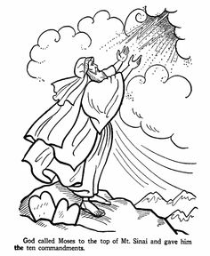

### Moses – God’s Faithful Servant of God

**THE TEN COMMANDMENTS**

Exodus 20: 1- 17 And God spoke all these words:

1. You shall have no other gods before me.
2. Do not make a graven image.
3. Do not use the name of the LORD your God in vain.
4. Remember the Sabbath day and keep it holy.
5. Honor your father and your mother.
6. Do not murder.
7. Do not commit adultery.
8. Do not steal.
9. Do not lie.

10.Do not covet or be jealous.

**Deuteronomy 32: 45-47** (The encouraging words of Moses to the Israelites near the end of his life)

“Take to heart all the words I have solemnly declared to you this day, so that you may command your children to obey carefully all the words of this law. **47**They are not just idle words for you—they are your life. By them you will live long in the land you are crossing the Jordan to possess.”

**The Song of Moses: Deuteronomy 32: 2-4**

Let my teaching fall like rain  
    and my words descend like dew,  
like showers on new grass,  
    like abundant rain on tender plants.

**3**I will proclaim the name of the Lord.  
    Oh, praise the greatness of our God!  
**4**He is the Rock, his works are perfect,  
    and all his ways are just.  
A faithful God who does no wrong,  
    upright and just is he.

**Deuteronomy 32: 45-47** (The encouraging words of Moses to the Israelites near the end of his life)

“Take to heart all the words I have solemnly declared to you this day, so that you may command your children to obey carefully all the words of this law. **47**They are not just idle words for you—they are your life. By them you will live long in the land you are crossing the Jordan to possess.”

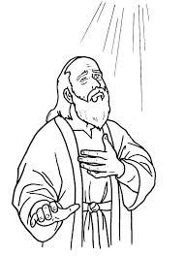

[Numbers 12:3](https://www.biblegateway.com/passage/?search=Numbers+12:3&version=NIV) (Now Moses was a very humble man, more humble than anyone else on the face of the earth.)

**NOTE:**

### Simulated Holy Land Tour through the Eyes of Moses and Joshua

are available in another electronic document. This is an in-dept study of the life of Moses and Joshua.

Pictures to support lesson if necessary.

|  |  |  |
| --- | --- | --- |
| <https://ancientexodus.com/> Best research  Traditional maps of the Exodus.  <https://www.google.com/search?q=traditional+map+exodus+route+israelites+egypt&sxsrf=ACYBGNTAPmkHwN09hclZARbie-ciVF4-ZA:1567913124652&tbm=isch&source=iu&ictx=1&fir=Kknh4ltt4qFzZM%253A%252C8-K_EROhWWYHNM%252C_&vet=1&usg=AI4_-kQDweA59qH12uqmQmGLIo1DVQPNcA&sa=X&ved=2ahUKEwjDmNXGo8DkAhWFjp4KHYWBAlAQ9QEwAHoECAgQBg#imgrc=N7QnbxF7aVZp9M:&vet=1> | exodus, glen fritz, ancient exodus |  |
| https://ancientexodus.com/wp-content/uploads/2018/07/Figure-1-Overview-Map.jpg |  |  |
|  |  |  |
| C:\Users\User\Documents\1 2017 Joshua duplic copies\moses_mount_fire2.jpg C:\Users\User\Documents\1 2017 Joshua duplic copies\moses_climbing.jpg C:\Users\User\Documents\1 2017 Joshua duplic copies\moses_commandments.jpgC:\Users\User\Documents\1 2017 Joshua duplic copies\tabernacle in desert.jpg | C:\Users\User\Documents\1 2017 Joshua duplic copies\golden-calf dancing around.jpg |  |
|  |  |  |
| C:\Users\User\Documents\1 2017 Joshua duplic copies\IsraeliteCampInWilderness.jpg |  |  |
|  |  |  |
| C:\Users\User\Documents\1 2017 Joshua duplic copies\about 10_Commandments._1 john 5 3.jpg | C:\Users\User\Documents\1 2017 Joshua duplic copies\ARK-OF-THE-COVENANT-310x165.jpg |  |
| C:\Users\User\Documents\1 2017 Joshua duplic copies\Ark-priests.jpg | C:\Users\User\Documents\1 2017 Joshua duplic copies\12_spies.jpg |  |
|  | Joshua and Caleb carrying the Grapes from Hebron. The other 10 spies follow. |  |
| C:\Users\User\Documents\1 2017 Joshua duplic copies\korah-challenges-moses.jpg  Korah challenges Moses |  |  |

### Joshua

**Simulated Holy Land Tour through the Eyes of Moses and Joshua**

**Teacher’s Guide and 11 PowerPoint Lessons**

### Samuel

### David

### Solomon

### Naaman’s Daughter

Naaman Healed of Leprosy2 Kings 5:1-15

**5**Now Naaman was commander of the army of the king of Aram. He was a great man in the sight of his master and highly regarded, because through him the Lord had given victory to Aram. He was a valiant soldier, but he had leprosy.[[a](https://www.biblegateway.com/passage/?search=2%20Kings+5&version=TLV;NIV" \l "fen-NIV-9649a" \o "See footnote a)]

**2**Now bands of raiders from Aram had gone out and had taken captive a young girl from Israel, and she served Naaman’s wife. **3**She said to her mistress, “If only my master would see the prophet who is in Samaria! He would cure him of his leprosy.”

**4**Naaman went to his master and told him what the girl from Israel had said. **5**“By all means, go,” the king of Aram replied. “I will send a letter to the king of Israel.” So Naaman left, taking with him ten talents[[b](https://www.biblegateway.com/passage/?search=2%20Kings+5&version=TLV;NIV#fen-NIV-9653b)] of silver, six thousand shekels[[c](https://www.biblegateway.com/passage/?search=2%20Kings+5&version=TLV;NIV#fen-NIV-9653c)] of gold and ten sets of clothing. **6**The letter that he took to the king of Israel read: “With this letter I am sending my servant Naaman to you so that you may cure him of his leprosy.”

**7**As soon as the king of Israel read the letter, he tore his robes and said, “Am I God? Can I kill and bring back to life? Why does this fellow send someone to me to be cured of his leprosy? See how he is trying to pick a quarrel with me!”

**8**When Elisha the man of God heard that the king of Israel had torn his robes, he sent him this message: “Why have you torn your robes? Have the man come to me and he will know that there is a prophet in Israel.” **9**So Naaman went with his horses and chariots and stopped at the door of Elisha’s house. **10**Elisha sent a messenger to say to him, “Go, wash yourself seven times in the Jordan, and your flesh will be restored and you will be cleansed.”

**11**But Naaman went away angry and said, “I thought that he would surely come out to me and stand and call on the name of the Lord his God, wave his hand over the spot and cure me of my leprosy. **12**Are not Abana and Pharpar, the rivers of Damascus, better than all the waters of Israel? Couldn’t I wash in them and be cleansed?” So he turned and went off in a rage.

**13**Naaman’s servants went to him and said, “My father, if the prophet had told you to do some great thing, would you not have done it? How much more, then, when he tells you, ‘Wash and be cleansed’!” **14**So he went down and dipped himself in the Jordan seven times, as the man of God had told him, and his flesh was restored and became clean like that of a young boy.

**15**Then Naaman and all his attendants went back to the man of God. He stood before him and said, “Now I know that there is no God in all the world except in Israel. So please accept a gift from your servant.”

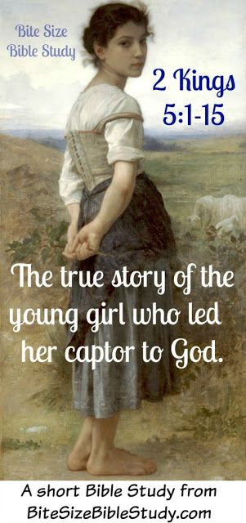

### King Josiah

### King Jorash

### John the Baptist

### 

### Jesus

**Summer Bible Club**

**“The Good News of Yeshua (Hebrew for Jesus)- The Miracles of Yeshua”**

**Themes: Yeshua identity, the mission, the calling …**

**Themes:**

* Yeshua’s identity (Who was he?),
* Yeshua’s mission (What did He Do?),
* What was Yeshua’s calling? (Why did he come to this earth?)
* Our decision to follow Yeshua, to tell others about him.

*SECTION # 1* - **Who is Yeshua?** (His Identity)

Yeshua’s identity and experiences in life

1. ***Lesson #1*** - **Who is Yeshua?** (His Identity)

**Introduction:**

**ACTIVITY:** Ask the children:

* + 1. What do you know about Yeshua?
    2. Who was Yeshua? Look up references for the following.
    - ‘God’”; ‘The Son of God’; ‘The Spirit of God’(Genesis ); ‘The Good News’ (References); The Lord – God (References); ‘Messiah’ (References); ‘Saviour’ (References); ‘Coming King’ (References); ‘Name above all Names’(References); ‘Alpha & Omega’ (References);
    - ‘a baby born to Mary, a virgin’ (Reference).
    - God was his heavenly Father (Reference); Joseph was the earthly father who took care of Yeshua on earth while he was growing up (Reference).

**ACTIVITY** 67 minutes**:**

*Watch* “The Story of Jesus for Children ([www.jesusfilm.org](http://www.jesusfilm.org)) – includes all of the components of this series of lessons.

*Ask children* to look for their favourite part to discuss later.

1. ***Lesson #2*** - **Who is Yeshua?** (His Identity)
   1. ***Introduction:***

**ACTIVITY:** Ask the children reviewing the story from :

* + Tell us what you know about the story of the **miracle of his birth**, his life (main events):
  + In the Scriptures Yeshua’s birth was foretold (References)
    - Children read verses … (References)
    - To be the Messiah and coming King – King Messiah Yeshua
      * **The angels** announced Yeshua’s birth … (References)
      * The **shepherds** came to see Yeshua …
      * The **wisemen** came seeking Yeshua – they came from afar …
      * **Blessed** **by Simeon** in the temple
      * **Fleeing** with Mary and Joseph to Egypt as a child to escape from Harrod
      * **Going to the temple** at age 12
      * **Growing up** in Nazareth
      * **40 Days being taught by God** in the wilderness…

[**Matthew 4:2**](https://www.biblegateway.com/passage/?search=Matthew+4:2&version=CJB) **-** After Yeshua had fasted **forty** **days** and nights, he was hungry.

[**Mark 1:13**](https://www.biblegateway.com/passage/?search=Mark+1:13&version=CJB) **-** and he was in the wilderness **forty** **days** being tempted by the Adversary. He was with the wild animals, and the angels took care of him.

[**Luke 4:2**](https://www.biblegateway.com/passage/?search=Luke+4:2&version=CJB) **-** for **forty** **days** of testing by the Adversary. During that time he ate nothing, and afterwards he was hungry.

[**Acts 1:3**](https://www.biblegateway.com/passage/?search=Acts+1:3&version=CJB) **-** After his death he showed himself to them and gave many convincing proofs that he was alive. During a period of **forty days** they saw him, and he spoke with them about the Kingdom of God.

* + - * **Being baptized** before he got started on his mission from the Complete Jewish Bible

Assignment: Go to [www.Biblegateway](http://www.Biblegateway) and look up references for Being Baptized.

Why is this mentioned so many times?

Identifying Yeshua as God’s chosen one and **Yeshua’s Mission of performing miracles and teaching.**

* + - * **Performing miracles**: Years of identifying who He was,
      * **Selecting and teaching** His disciples
      * **Challenging leaders** in the Sanhedrin, those who wanted him killed?

**Identifying** Yeshua as God’s chosen one and **Yeshua’s Calling.**

* + - * **Dying on the tree for our sins**
      * **Rising on the third day – the Resurrection**
      * **Sending the Holy Spirit on Pentecost to be our comforter and guide**

What is our identity?

Who are we?

* + **Outcome**: - What is our identity? -
    - Who are we? (special people created by God, created in God’s image, loved by our parents, family, friends, the Temple of God, etc.)
    - Who are we if we have Yeshua in our heart and life? – Children in God’s family, our name is written in the Lamb’s book of life.
      * Who does Yeshua want us to be?
      * What does Yeshua want us to do?
      * Why does Yeshua want us to do this?
      * When should we do these things?
  + **Songs** – On my father’s Side (video from YouTube)
    - about the miracle of his birth and being a light to the world
    - Hebrew Songs of adoration
    - Hebrew Dance of adoration
  + **Bible verse –**
  + **Picture Book Activity** – children tell the story of Yeshua – the child and young boy - making a picture book of these events
    - A baby is born in Bethlehem
    - Simeon announces – now I have seen …
    - a young boy who at 12 yrs challenged the temple priests knew God – was about his father’s business
    - a man who did miracles a man who taught others about the amazing God we have
    - a man who had a short ministry with children, youth, adults
  + Sharing and celebrating what is so great about “The Good News of Yeshua?”
  + Learning to Pray
    - Yeshua taught His disciples: The Lord’s prayer

1. SECTION # 2 – **Yeshua’s Mission…** What did Yeshua do while He was on earth? Tell or share “The Good News”…
   * The story
     + How did Yeshua tell the “The Good News” – in miracles …
       - Water into wine – first miracle - Cana
       - Healing … movie clips ...

**Yeshua’s Mission**: Miracles preformed in 3 years of Yeshua’s ministry.

* + - * + The blind –Bartimaeus – how many blind men did Jesus heal”

Yeshua speaks about being blind many times: Let’s learn about all the ways that we might be blind

* + - * + The deaf
        + Lame man
        + Raised the dead: Jarius daughter who dies, Lazarus Yeshua’s good friend
        + The sick … leprosy was a common disease
        + The sick in heart – the beatitudes
        + Water - Walked on the water, made water into wine, calmed the storm, was baptized

Yeshua’s Calling?

* 1. Introduce Yeshua’s Mission and Calling (Purpose)

The miracles illustrated:

* God living among us. Yeshua was the flesh, the man, but he was actually God on earth.
* God’s love for man
* Teaching people, healing people
* To show the power of God through the amazing man ‘Yeshua’
* PURPOSE: to die for our sins and to bring salvation to all people
* **To make us** **anew** and **born from above** (YouTube: Marty Goetz and Jennifer & Misha)
  + **Dying on the tree for our sins**
  + **Rising on the third day – the Resurrection**
  + **Sending the Holy Spirit on Pentecost**
  + **Returning for those who have given their heart and life to Yeshua to take them to heaven with him.**
  1. **What is our mission on earth?**

What is our mission on earth?

What is our calling (purpose)?

* + - To be a witness for Yeshua by how we act, talk, behave…
    - To read, study and obey God’s word
    - To pray
    - To tell others about Yeshua
    - To Pray
    - To serve Yeshua and others
  1. **Songs** – On my father’s Side (video from YouTube)
     + Songs about miracles
     + Songs of adoration
     + Dance of adoration
  + **Bible verse:**
  + **Picture Book Activity** – Picture on Map of Canaan – glue in pictures in the places where the miracles took place
  + **Sharing and Celebrating** what is so great about “The Good News of Yeshua?”
  + **Learning to Pray**

1. SECTION # 3 - **Yeshua’s Mission .. continued …** Where did Yeshua’s beautiful feet go telling the Good News and to teach.

Beautiful are the feet of those Romans 10:15

Other words to search – feet, taught in parables, object lessons or stories that we could understand

1. The Story
   * Judea, Samaria, Galilee, Jerusalem, Decapolis
2. **Songs** – On my father’s Side (video from YouTube)
   * About beautiful feet
   * Songs of adoration
   * Dance of adoration
3. Bible Verse
4. Picture Book Activity - Map Activity

What is our mission on earth?

1. Sharing and celebrating what is so great about “The Good News of Yeshua?”
2. Learning to Pray
3. SECTION # 4 - **Yeshua’s Mission…** **continued** …Where did Yeshua go to share God’s Words as “The Good News”– a light to the path of Others and to Us?

To whom did Yeshua bring “The Good News”? The poor, the gentiles ‘goyuim’ in the Decapolis, in the Galilee, Jerusalem

* + The Story
  + **Songs** – On my father’s Side (video from YouTube)
  + Bible Verse

1. Picture Book Activity – Map Activity – in Canaan
2. Sharing and celebrating what is so great about “The Good News of Yeshua?”
   * Learning to Pray
3. SECTION #5. Yeshua’s Calling…. His purpose on earth
   * What was Yeshua’s purpose on earth?

The miracles illustrated:

* God living among us. Yeshua was the flesh, the man, but he was actually God on earth.
* God’s love for man
* Teaching people, healing people
* To show the power of God through the amazing man ‘Yeshua’
* PURPOSE: to die for our sins and to bring salvation to all people
* **To make us** **anew** and **born from above** (YouTube: Marty Goetz and Jennifer & Misha)
  + **Dying on the tree for our sins**
  + **Rising on the third day – the Resurrection**
  + **Sending the Holy Spirit on Pentecost**
  + **Returning for those who have given their heart and life to Yeshua to take them to heaven with him.**
  1. **What is our calling** (Purpose)?

1. SECTION # 6 – Our identity as children of God? Our Mission? Our Calling?

What is our identity?

Who are we?

* + What is the Good News?
    - John 3:16 – Look it up…
  + Why is it so important to Share “The Good News”?
* Joy in heaven when one sinner comes to know Yeshua
* Peace in our heart
* Love flows over in our heart
* Share the ‘Joy in our heart’ with others – If the News of Yeshua is so good and gives us such joy – do we want to keep it to ourselves?
  + Examples of Yeshua sharing “The Good News” – from the New Testament…
  + Nicodemus
  + Zaccheaus
  + Yeshua calling the disciples

1. Examples of Songs
   * About joy in heaven
   * Songs of adoration
   * Dance of adoration
2. Find a Bible Verse about sharing the Good News
3. Picture Book Activity
   * Sharing and celebrating what is so great about “The Good News of Yeshua?”
4. Learning to Pray
5. SECTION # 6 - How can/do we share "The Good News of Yeshua?”
   * The Story
     + At [www.jesusfilm.org](http://www.jesusfilm.org) watch “The Story of Jesus” for Children
     + Then at the same place go to Story Club and watch the clips and discuss this with the students.
     + Inviting friends to kids clubs
   * Songs
   * Bible Verse
   * Picture Book Activity - Map Activity in Canaan
   * Sharing and Celebrating what is so great about “The Good News of Yeshua?”
   * Learning to Pray
6. SECTION # 7 – Actively sharing the Good News with others – Going out to do this in our community or with our friends…
   * Where and When do/or can we share “The Good News of Yeshua?”
   * The Story
   * Songs
   * Bible Verse
   * Picture Book Activity - Map Activity – world map
   * Sharing and Celebrating what is so great about “The Good News of Yeshua?”
   * Learning to Pray
7. SECTION # 8 - What is it that is so great/amazing/wonderful about “Yeshua?”

* Salvation
* Yeshua is the light of the world
* Peace
* Our only Hope
  + The Story
  + Songs
  + Bible Verse
  + Picture Book Activity - Map Activity – world map
  + Sharing and Celebrating what is so great about “The Good News of Yeshua?”
  + Learning to Pray

9. SECTION # 9 - Children complete unfinished work, celebrate what they have learned and prepare for their presentation next Shabbat.

10. SECTION # 10 - Children share “the Good News of Yeshua” with the congregation

**11. Assignment:**

**Go to Bible Gateway and look up all the references for GOOD NEWS and see how many there are in the Bible**

**For Example – there are 140 references in the Complete Jewish Bible . How many are there in other translations.**

**Who is the Good News?**

**Exam the references in the Old Testament. Who did this refer to?hy did this**

### Story of Jesus for Children Movie

* [www.Jesusfilm.org](http://www.Jesusfilm.org)
* YouTube

|  |  |  |  |
| --- | --- | --- | --- |
| (Min:Sec) | **Story of Jesus Sequence of Events Gospel of Luke** | Book of Luke | Other References |
| 00:00 | Birth of Jesus | Luke 1:26 | Matthew 1:18-22  Mark, John, |
| 5:00 | Jesus in Jerusalem at age 12 | Luke 2:41-52 |  |
| 5:30 | John the Baptist - Baptism of Jesus | Luke 3:21-23 |  |
| 6:30 | Jesus teaching, Reading scripture in Nazareth, Galilee | Luke 4:14-22 |  |
| 7:50 | Miraculous catch of fish | Luke 5:1-11 |  |
| 9:30 | Admonition of Peter (“Depart from me”) | Luke 5:8; 13:27 |  |
| 10:50 | Jesus teaching in the temple | Luke 4:16 |  |
| 11:20 | Healing 12 –year-old girl –Jarius’ daughter | Luke 8:41-56 |  |
| 12:42 | Call of Matthew | Luke 5:27 - 30 | Matthew 9:9-12 |
| 13:30 | Call of the disciples - Consider the price people paid to follow Jesus. | Luke 6:12-16 | Peter & Andrew Matthew 4:18-20 |
| 15:30 | Sermon on the Mount | Luke 6:27-31 | Matthew 5: 38-42 |
| 16:45 | Mary washes Jesus’ feet | Luke 7:36-50 |  |
| 19:15 | Parable of the soils and sower | Luke 8:4-15 |  |
| 21:00 | Calming the storm | Luke 8:22-25 |  |
| 22:30 | Feeding the Multitude – 5000 5 loaves 3 fish | Luke 9:10-17 |  |
| 25:30 | Parable of the Good Samaritan | Luke 10:25-37 |  |
| 27:30 | Healing of blind Bartimaeus | Luke 18:35-43 |  |
| 28:30 | Zacchaeus | Luke 19:1-10 |  |
| 30:30 | Jesus sets his Face to Jerusalem |  |  |
| 31:00 | Triumphal Entry into Jerusalem | Luke 19:35-40 |  |
| 32:00 | Cleansing the Temple | Luke 19:45-48 |  |
| 33:00 | Widow’s Might | Luke 21:1-4 |  |
| 34:00 | “Render unto Caesar that which is Caesar’s” | Luke 20:20-26 |  |
| 34:30 | Market Scene --- grinding meal |  |  |
| 35:00 | The Last Supper | Luke 22:14-23 |  |
| 37:00 | Judas betrays Jesus, Jesus is arrested  Jesus restores the servants ear | Luke 22:47-48  Luke 22:49-53 |  |
| 39:30 | Mocking Jesus, Peter’s Betrayal | Luke 22:63-65  Luke 22:33-62 |  |
| 42:00 | Jesus before the Sanhedrin | Luke 22:66-23:25 |  |
| 43:00 | Jesus before Pilate | Luke 22:66-23:25 |  |
| 48:00 | Crucifixion | Luke 23:26-49 |  |
| 53:00 | Burial | Luke 23:50-56 |  |
| 54:00 | Resurrection | Luke 24:1-12 |  |
| 56:30 | Post-resurrection appearance of Jesus | Luke 24:13-35 |  |
|  | The prayer to accept Jesus |  | John 3:16 & 17 |

### Develop lessons surrounding the following children in the Bible:

### Jarius Daughter

### The Boy with the Loaves & Fishes

### Timothy