The Fruit of the Spirit
Is:
Love
Joy
Peace PatienceKindness
Goodness
Faithfulness
Gentleness
Self-Control
Against this there is no law.
Galatians 5:22 & 23

Making the Accordion Poster:
- To save ink when printing the letters, use light gray. Then outline the words by hand with felt pens or crayons and colour them in so that the word is solid for children to read..
- Colour the letters in with a felt to make a solid letter or cross-hatch with coloured pens/pencils that are narrow.
- Paste the words using glue onto coloured or black cardstock or construction paper
- Cut strips of clear packing tape and paste over top of the words to make them stick to the cardstock or coloured construction paper.
- When taping the words together, leave a space between the sheets of cardstock so that the words so that they can be folded up like an accordion.

3/8 “space between words strip of packing tape on both sides of cardstock over the space creates stability
Faithfulness
Goodness
and it does not stick together

in order to reinforce the edges after all of the words are taped together, tape the top and bottom edges. Also tape the entire poster along all edges on the front and back. This creates a strong accordion style poster that can be folded easily for transporting. Kids love it when the poster unfolds and the words all spill out.
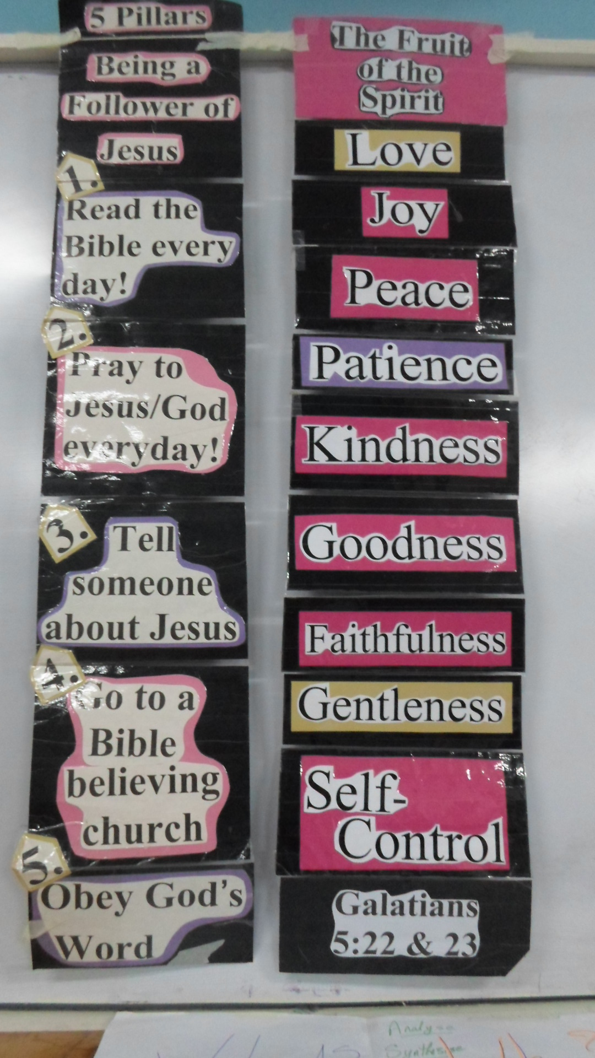
Gentleness

