5 Pillars for being a follower of Jesus:

This poster is meant to be a numbered list
Read your Bible

Pray Everyday

Tell Someone About Jesus
Obey God’s Word

God to a Bible Believing Church
Tape together with packing tape.
NOTE:
The same type of poster can be made for the fruit of the spirit.

It is shown in the Teacher Lesson Book “Applying Values and Virtues of Character Across Subjects”

5 Pillars for being a follower of Jesus:
- Read your Bible
- Pray Everyday
- Tell Someone About Jesus
- God to a Bible Believing Church
- Obey God’s Word

  - Pillars
2.
3.
for Being a Follower of Jesus
5.
4. .
1.
Read the Bible Every Day!
Pray to Jesus
Every Day!
Tell Someone About Jesus!
Go to a Bible
Believing Church.
Obey God’s Word!

Making the Accordion Poster:
- To save ink when printing the letters, use light gray, or use an open style test to allow for colouring.. Then outline the words by hand with felt pens or crayons and colour them in so that the word is solid for children to read..
- Colour the letters in with a felt to make a solid letter or cross-hatch with coloured pens/pencils that are narrow.
- Paste the words using glue onto coloured or black cardstock or construction paper
- Cut strips of clear packing tape and paste over top of the words to make them stick to the cardstock or coloured construction paper.
- When taping the words together, leave a space between the sheets of cardstock so that the words so that they can be folded up like an accordion.
- Type the numbers for each pillar in the star shape and glue on the right hand corner.

3/8 “space between words strip of packing tape on both sides of cardstock over the space creates stability
Read the Bible
Pray everyday
Etc.
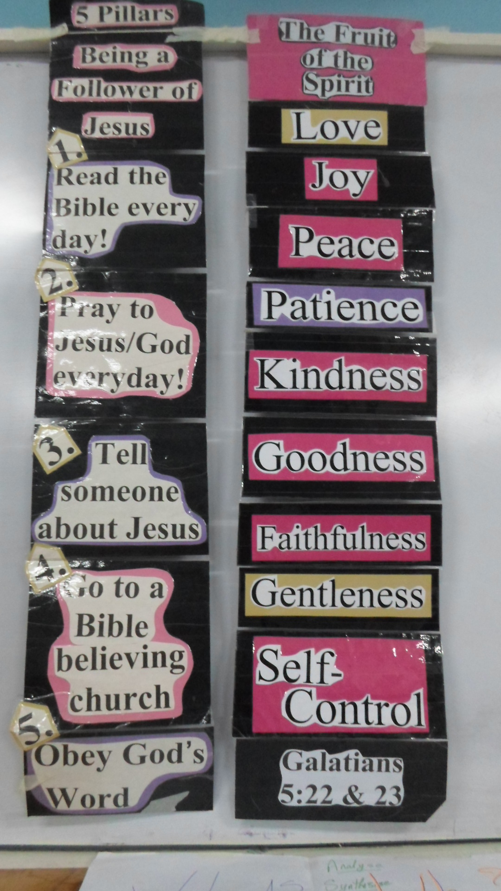
and it does not stick together

in order to reinforce the edges after all of the words are taped together, tape the top and bottom edges. Also tape the entire poster along all edges on the front and back. This creates a strong accordion style poster that can be folded easily for transporting. Kids love it when the poster unfolds and the words all spill out.

